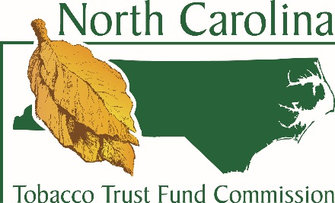
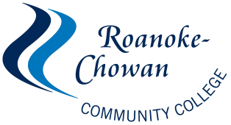
Project Skill-UP Application

Personal Information

1. Full Legal Name:__________________________________________________________________________
2. Mailing Address:__________________________________________________________________________
3. City, State, Zip Code:_______________________________________________________________________
4. County of residence:________________________________________________________________________
5. E-mail address:____________________________________________________________________________
6. Phone Number:______________________________ 7. Cell Number:_____________________________
8. Date of Birth:________________________________ 9. Facebook Alias:___________________________
Eligibility please check all that apply

Family Unit | 200% of poverty guidelines
1 | 22,980
2 | 31,020
3 | 39,060
4 | 47,100
10. Employment Status
□ I am currently unemployed and looking for work.
□ I am working but earn less than 200% of the federal poverty guidelines and looking to advance in my career or make a job change.
□ Other (please explain):____________________________
Current Employer Name:______________________ _____ Job Title:________________________________

Tobacco and Agriculture Connection

11. Are you a former tobacco quota holder? | YES NO
12. Are you a current or former tobacco farmer? | YES NO
13. Do you have family members who have worked in the tobacco industry or tobacco farming? | YES NO
14. Have you become unemployed due to changes in the tobacco industry in the area? | YES NO
15. Does your family derive income from a farming enterprise? | YES NO

Class Information

Name of class seeking sponsorship for:
□CNA I day □CNA I night □CNA II day □CNA II night
□EMT Basic □Welding Plate □Certified Production Technician

For EMT and CNA courses please attach a copy of your TABE placement test scores. If you need to schedule this assessment please contact Beverly Goodwin at 862-1238. Applications that do not include placement test scores will be considered incomplete.
Impact Statement

Applicants must submit a short statement describing how the Project Skill-UP program will impact their training and employment goals. Explain why you need financial assistance and how the class you want to take will help you reach your career goals. Applications without the impact statement will not be considered.

I hereby verify that all the information given by me as written on this form is complete and accurate to the best of my knowledge. I will inform the Project Skill-UP Coordinator if my contact information changes and will provide updates on my progress in class and job search.

Signature:____________________________________________ Date:____________________

Completed applications should be returned to Andrea Glaze, Project Skill-UP Coordinator
Office: Student Service Center Building 214, 252-862-1202 aglaze1794@roanokechowan.edu
For Office Use Only

Date completed application received:________________ Career Readiness Certificate: Test Date:__________

Date acceptance letter mailed to participant:___________ Reason application was denied:_________________

Course Name | Course ID | Start Date | End Date | Course Status | Credentials Earned

Follow-up Notes:

Employer Name:___________________________ Job Title:____________________________

