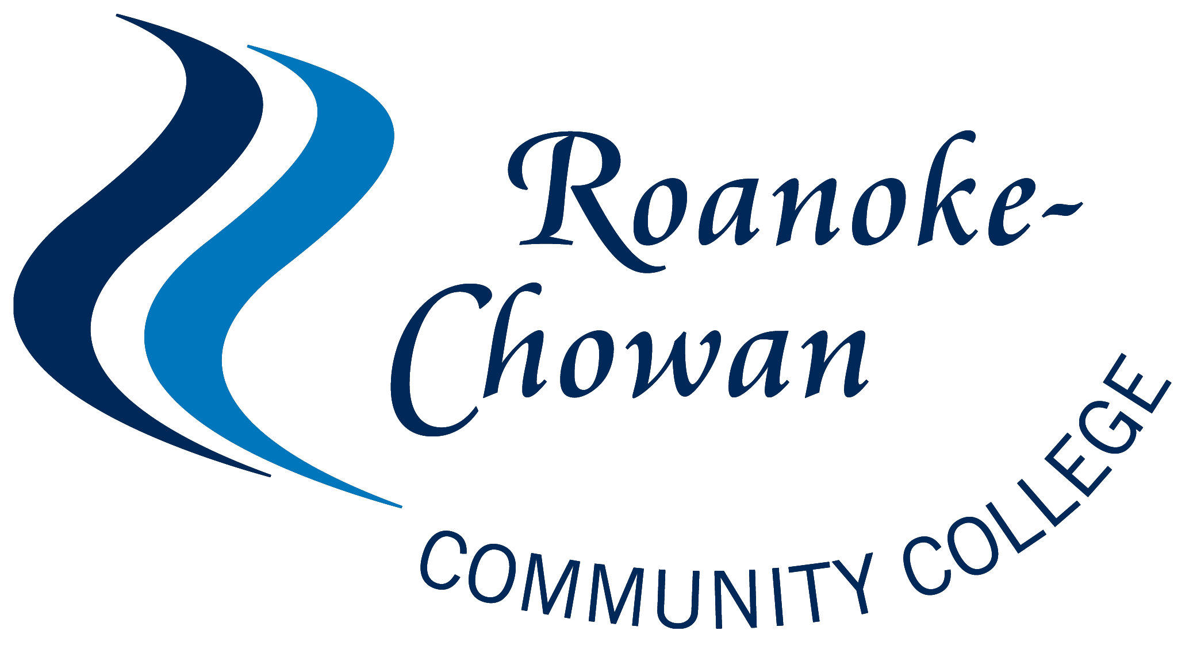

**State Employees’ Credit Union (SECU) Foundation**

**Continuing Education Scholarship Program**

**Roanoke-Chowan Community College**

**2020 – 2021 Student Application Form**

**Scholarship Eligibility:** To be considered for this scholarship program a student must be a US Citizen and a North Carolina resident and be in one of the following target groups: unemployment insurance claimants, unemployed or underemployed, military veterans and spouses, or a member of the NC National Guard. Scholarship funds for the fall semester will be distributed in **October 2020.** Scholarship funds for the spring semester will be distributed in **March 2021**. The value of the scholarship is **$500.00.**  The SECU Continuing Education is a competitive scholarship, while not need-based, preference will be given to students with limited or no access to financial aid from other programs.

**Scholarship funds may be applied to the following Continuing Education courses: Barbering, Certified Nursing Assistant I, Certified Nursing Assistant II, Commercial Driving License (CDL), Community Health Worker, Dietary Management, Emergency Medical Technician Basic (EMT), Medical Billing and Coding, Phlebotomy, Pharmacy Technician and Welding Plate.**

**Instructions:** Please complete this entire application in detail and turn in to the Financial Aid office. Incomplete or late applications may not be considered. If required, attach placement test scores to this application. Scholarships will be awarded based upon financial need for approved courses. All scholarship recipients will be required to complete a student data form, provide a student photo, and attend a recognition ceremony.

**Application Deadline: Fall Semester: September 25, 2020 Spring Semester: December 11, 2020**

**Personal Information:**

Full Legal Name:

Social Security Number: Date of Birth:

Are you a US Citizen? □yes □no

Are you a director, employee or family member of an employee of the State Employees’ Credit Union or SECU Foundation? □yes □no

Gender: □male □female

Race: □African American □Caucasian □Hispanic □Other (please specify)

Mailing Address:

City, State, Zip Code:

County of residence:

E-mail address:

Phone Number: Cell Number:

**Employment Status: please check all that apply**

□I am currently unemployed.

□I am receiving unemployment benefits.

□I am working less than 20 hours per week.

□I am working between 20 and 39 hours per week.

□I am working full time.

**Veteran Status: please check all the apply**

* I am a military veteran
* I am a member of the NC National Guard
* My spouse is a military veteran
* My spouse is a member of the NC National Guard
* None of the Above

How many people in your household?

**Other sources of Financial Aid:**  Are you receiving assistance from any of the following sources?

**Project Skill-Up**

* Receiving Assistance
* Applied for assistance waiting on notification
* Not receiving assistance

**WIOA**

* Receiving Assistance
* Applied for assistance waiting on notification
* Not receiving assistance

**Golden Leaf**

* Receiving Assistance
* Applied for assistance waiting on notification
* Not receiving assistance

**Other Third Party Sponsor – *Please Specify***

Have you previously received the State Employees Credit Union Continuing Education Scholarship?

* Yes
* No

**Income Verification:** Attach your most recent Federal Income Tax Return, verification of TANF/Snap Food Stamps, or low income verification form. If you are a dependent, you must provide a copy of your parent’s most recent tax form. Applications that do not include verification will be considered incomplete.

**Educational Information:**

**Please indicate the Continuing Education Course You Wish to Take:**

Course Name: Start Date:

* Barbering
* Certified Nursing Assistant I Day
* Certified Nursing Assistant I Night
* Certified Nursing Assistant II Day
* Certified Nursing Assistant II Night
* Commercial Driving License (CDL)
* Community Health Worker
* Dietary Management
* EMT Basic
* Medical Billing and Coding
* Phlebotomy
* Pharmacy Technician
* Welding Plate (Weekday and Weekend)

**For EMT, CNA I and Dietary Management courses, students please attach a copy of your TABE placement test scores or transcript showing completion of college level English course.**. If you need to schedule this assessment, please contact Ms. Edwina Vann at 862-1238. Applications that do not include placement test scores will be considered incomplete.

Please indicate your highest level of education completed:

□No High school diploma/GED □Associate Degree

□High School Diploma or GED □Bachelor’s Degree or more

□One Year Vocational Diploma

Are you a current R-CCC student? □Yes □No

How would these scholarship funds assist you in your career plans?

**Essay Question:**  To help the scholarship committee review your application please explain why you are a good candidate to receive this award.

***I hereby verify that all the information given by me as written on this form is complete and accurate to the best of my knowledge.***

* As a condition of the award, scholarship recipients must consent to the release of their names and images for publications written/distributed by the System Office, the local Community College, and/or the State Employees’ Credit Union and its Foundation. **Do you consent to the release of your name and photos for publications? Yes ________            No________**
* The **2020-21 Student Data & Consent Form** (Attached) must be utilized and submitted with the awardees initial status report.  **Have you completed the Student Data and Consent Form?**

**Yes ________     No____________**

* Colleges must invite representatives from the local State Employees’ Credit Union to present a certificate of award to the scholarship recipients during a designated recognition program hosted by the college. **Will consent to participate in scholarship recognition program? Yes ____  No_____**

Signature: Date: