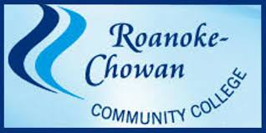
Is offering an
Initial CPR/BLS Provider Course
Date/Time: July 13th, 2022
Time: 6:00pm – 10:00pm
Location: Roanoke Chowan Community College/ Jernigan Building Room 113
Fees: $45.00 class cost + $5.00 for CPR card
Please contact Michael Barnes @ 252-287-6200 or 252-862-1266 to register and to hold your place in the class
