

**Faculty Handbook**

Prepared by

**The Office of Academic Affairs Faculty Handbook Subcommittee**

**Roanoke-Chowan Community College**

**109 Community College Road**

**Ahoskie, North Carolina 27910-9522**

Phone (252) 862-1200 Fax (252) 862-1358 [http://www.roanokechowan.edu](http://www.roanokechowan.edu/)

***Table of Contents***

I. **Scope and Rationale** 2

II. **Key Administrative, Curriculum, and Support Services Personnel** 4

III. **“Help Desk” Contacts and Extensions** 8

IV. **Instructional Policies and Information** 11

A. Academic Freedom 12

B. Intellectual Property 12

C. Family Educational Rights & Privacy Act 12

D. Professional Development 13

E-1 Faculty Workloads/Instructor Availability (F-T) 14

E-2 Faculty Workloads/Instructor Availability (P-T) 17

F. Instructor Absences 18

G. Course Schedule 18

H. Course Syllabi and Textbooks 19

I. Full Use of Scheduled Class Time 20

J. Class Roster and Record of Attendance 21

K. Assigning Final Grades 22

L. Evaluation of Instruction 24

M. Classroom Management 24

N. Field Trips 25

O. Photocopying 25

V. **Student Policies** 26

A. Course Load 27

B. Dropping and Adding Courses 27

C. Substituting Courses 28

D. Credit by Exam 28

E. Repeating Courses 28

F. Attendance Policy 29

G. Visitors/Children on Campus 31

VI. **General Information** 32

A. Contracts 33

B. Fringe Benefits 33

C. Equal Opportunity Policies 34

D. College/Workplace Anti-Violence Policy 35

E. Harassment 36

F. Non-Fraternization 38

G. Operational Hours 38

H. College Closings 39

I. Mailboxes 39

J. Travel 39

K. Secondary Employment 40

VII. **Learning Resources Center** 41

A. Learning Resources Center Mission 42

B. Operating Hours 42

C. General Procedures 42

D. Library Catalog 43

E. Finding Books or Audiovisual Software 43

F. Finding Periodical Articles 44

G. Electronic Resources 44

H. Newspaper Articles 45

I. Circulation Procedures and Library Cards 45

J. Audiovisuals 46

K. Books 46

L. Periodicals 46

M. Reference Books 46

N. Reserve Books 46

O. Holds 47

P. Overdue Materials 47

Q. Fines for Overdue Materials 47

R. Lost/Damage Materials 47

S. Computers 48

T. Internet and Computer Use 48

U. Online Database 49

V. LRC’s Libguides 49

***Additional LRC Services***  50

1. Copy Machine 50
2. Fax Machine 50
3. Interlibrary Loan Services 50
4. Lamination 50
5. LRC Orientation 50
6. LRC Café and Food Services 51
7. Small Group Study Rooms 51
8. Computer-Assisted Instruction Lab 51

VIII. **Distance Learning** 52

1. Distance Learning 53

IX. **Constitution and By-Laws** 54

X. **Appendices** 60

1. Travel Reimbursement 61
2. Travel Request 62
3. Class Coverage/Make-Up Schedule 63
4. Curriculum Master Schedule 64
5. Drop/Add Form 65
6. Grade Change Report 66
7. Notification of Approval for “W” Grade 67
8. Request to Register for Independent Study 68
9. Syllabi Template 70
10. Web Attendance Quick Guide 76
11. Campus Directory 81
12. Leave Request 82
13. Request for Approval of Secondary Employment 83

**I**

**Scope and**

**Rationale**

Welcome to Roanoke-Chowan Community College. This Faculty Handbook is being made available to faculty as a reference guide for important instructional, student services, and general policies relevant to their role as a faculty member.

Because there is so much information that faculty need to know that it cannot possibly be contained in one location, faculty are encouraged to consult the Roanoke-Chowan Community College website (www.roanokechowan.edu), their lead faculty, division director, and their fellow faculty whenever the information they are seeking cannot be found in this handbook or when more information about a topic is only briefly described here. Additionally, the staff in the Office of the Dean of Academic Affairs is always available to address any questions or concerns faculty may have.

Again, welcome to R-CCC where we are ***Changing Lives Through Learning***!

**II**

**Key Administrative, Curriculum, and Support Services Personnel**

Most instruction at Roanoke-Chowan Community College (hereinafter referred to as “*R-CCC*” or “*the College*”) falls under the broad administrative umbrella of the Curriculum Programs Division, presided over by Dr. Adriane Leche, Dean of Academic Affairs; thus, the administration for curriculum instructional programs and of the faculty/instructors therein falls under the supervision of the dean. As is the case with any successful organization, the Curriculum Programs Division works in tandem with other divisions and/or units of the College to achieve curriculum goals. The following is a list of people that faculty will have the need to call upon at varying times during their time at the College.

**Office of the President**

Dr. Audre Levy, Interim President

Jernigan106A

252-862-1308, laurelevy@gmail.com

Renicka Vaughan, Executive Assistant to the President

Jernigan 106

252-862-1308, rnvaughan@roanokechowan.edu

**Academic Affairs**

Dr. Adriane Leche, Dean of Academic Affairs

Jernigan 104

252-209-8420, aleche@roanokechowan.edu

Ernestine Britt, Administrative Assistant to Dean of Academic Affairs

Jernigan 104

252-209-8420, ecbritt@roanokechowan.edu

Kimberly Harrell, Associate Dean of Academic Affairs/Division Director, Health Sciences and Human Services

Jernigan 119A

252-862-1288, kharrell@roanokechowan.edu



**Division Directors**

Teikeshia Archer, Division Director: Business and Vocational/Industrial Technologies

Freeland 143

252-862-[1218, tmarcher6934@roanokechowan.edu](mailto:tmarcher6934@roanokechowan.edu)

Kimberly Harrell, Division Director: Health Sciences and Human Services

Freeland 119A

252-862-1288, kharrell@roanokechowan.edu

Fannie Pugh, Division Director: College Transfer, General Education and Public Services

Jernigan 122

252-862-1254, ftpugh5693@roanokechowan.edu



**Lead Faculty**

John Mulder, Lead Faculty: Vocational/Industrial Technologies

Young 122

252-862-1372, jlmulder7174@roanokechowan.edu

Jeanette Pellegrin, Lead Faculty: Fine Arts & Sciences

Student Support Services 213

252-862-1263, jlpellegrin@roanokechowan.edu

Shannon Harrell, Lead Faculty: Human and Public Services

Freeland 102A

252-862-1213, sbharrell@roanokechowan.edu

Michael Jefferson, Lead Faculty: English, Humanities, Math, & PE

Student Support Services 219

252-862-1375, mjefferson7176@roanokechowan.edu

Latoya Stephenson, Lead Faculty: Business Technologies

Freeland 147C

252-862-1296, lfstephenson8583@roanokechowan.edu

Dr. Michelle Warren, Lead Faculty: Health Sciences/Director ADN

Freeland 129A

252-862-1327, mwarren5623@roanokechowan.edu

**Student Development Services/Financial Aid**

Jumond Darius Greene, Dean of Student Services -Vacant

Student Services Center 111F

252-862-1267

Dr. Tanya Oliver, Director of Student Support Services

Student Services Center 113A

252-862-1272, [toliver@roanokechowan.edu](mailto:toliver@roanokechowan.edu)

Ruchelle Ricks, Director of Financial Aid

Student Services Center 111C

252-862-1246, rricks@roanokechowan.edu

**Information Systems Technology**

Dr. Mary Leary, Dean of Institutional Support/CIO/Acting President

Jernigan 110

252-862-1302, meleary3157@roanokechowan.edu

Michael Wilson, Systems Administrator

Jernigan 110

252-862-1240, mwilson@roanokechowan.edu

Sherrick Mizelle, PC Web Tech

Jernigan 110

252-862-1206, smizelle@roanokechowan.edu

Christopher Douglas, Network Administrator

Jernigan 110

252-862-1371, cadouglas@roanokechowan.edu

**III**

**“Help Desk” Contacts and Extensions**

Campus Extensions

**College Switchboard: 252-862-1200 or 0 (from inside)**

To dial any of the following numbers from on campus, just dial the last three digits of the phone number. For example, to call the Registrar from on campus, dial **225** instead of 252-862-1225. After 5:00 PM, calls are forwarded to the security office. In the event that you do not get an answer, please dial extension 219 to reach the security office.

**If you have questions regarding… Call. . . Extension**

• Administrative Affairs President 308

• Admissions Director of Enrollment Management 246

• Moodle ™ (online instruction) Director of Distance Learning 242

• Book Store Bookstore Manager 292

• Classroom Assignments, Course

Changes

Administrative Assistant to the Dean of Academic Affairs

381

• Computer (Staff), Telephone, and

Network Problems

Director of Information Systems

302

• Curriculum, Instruction Dean of Academic Affairs 287

• Disability Services Registrar 225

• Email Access Director of Information Systems

302

• Facility Maintenance Maintenance & Grounds Supervisor 351

• Financial Aid Financial Aid Director 246

• Housekeeping Custodial Services Supervisor 351

• Job Placement JobLink Manager 277

• Learning Resources

Center/Library

Director of Learning Resources

Center

239

• Payroll Payroll Technician 217

• Personnel/Contract Issues Director Human Resources 310

• Registration Issues and Grade

Forms

Registrar 225

• Reimbursements Accounts Payable

Technician/Sponsorship Specialist

229

• Scheduling a Library/Research Orientation or Reserving Audio/Visual Equipment

Library 209

|  |  |  |
| --- | --- | --- |
| • Scheduling a Meeting with the  President | Executive Administrative Assistant to the President | 308 |
| • Security | Campus Security | 219 or 0 |
| • Student Concerns | Dean of Student  Services | 267 |
| • Travel Requests | Purchasing Agent | 228 |
| • Tutoring Services | Student Support Services Secretary | 303 |
| • Veterans’ Assistance | Dean of Student  Services | 267 |

**IV**

**Instructional Policies and**

**Information**

# A. Academic Freedom

The Board of Trustees of Roanoke-Chowan Community College has adopted the following principles of academic freedom:

* The first obligation of every instructor is to do the best job of teaching of which he is capable. However, he has freedom to engage in research and development and may publish the results of such endeavors, provided these activities do not in any way interfere with his teaching duties.
* The instructor is entitled to freedom in the classroom in discussing his subject, but should be careful not to introduce into his teaching controversial matter which has no relation to his subject.
* The instructor is a citizen, a member of a learned profession, and an officer of an educational institution. When he speaks or writes as a citizen, he should be free from institutional censorship or discipline, but his special position in the community imposes special obligations. As a person of learning and an educational officer, he should remember that the public may judge his profession and his institution by his utterances. Hence, he should at all times be accurate, should exercise restraint, and should show respect for the opinions of others, and should make every effort to indicate that he is not an institutional spokesman.

# B. Intellectual Property

The College encourages the development, writing, invention, or production of intellectual property designed to improve the productivity of the College or to enhance the teaching/learning environment.

Faculty, staff, and students, utilizing college time, property and/or materials, may create work that is subject to the College’s intellectual property protection. The College will have exclusive rights to and ownership of such work; in addition, faculty, staff, and students will make such work available for use to the College without the expectation of further compensation.

The ownership of a copyright or patent resulting from the development of intellectual property and any rewards or recognition attributed to the copyright or patent will be determined based on the criteria established in Board Policy 8.10 (available on R-CCC’s shared drive – S:/Human Resources/Board Policies Manual).

# C. Family Educational Rights & Privacy Act of 1974 FERPA

The Family Educational Rights and Privacy Act of 1974 (P.L.93-380, S513) signed by the President of the United States became law as of November 9, 1974. Included in this law are requirements related to the privacy of student files and records.

The law specifically states that no institution of higher education shall prevent its students from inspecting and reviewing “all official records, files, and data including all material that is incorporated into each student’s cumulative folder.”

Although that act specifically refers to the access rights of parents, it provides that “whenever a student has attained 18 years of age or is attending an institution of postsecondary education, the permission or consent required of and the rights accorded to the parents of the students shall thereafter only be required of and accorded to the student.”

The only individuals or agencies authorized to see a student’s record, other than the student, without the student’s written consent, are school officials with “legitimate” educational interests, officials of other schools in which the student “intends to enroll,” and certain government representatives. Students interested in reviewing their files must see the Registrar or Information Processing Specialist.

The College may disclose, without consent, "directory" information such as a student's name, address, telephone number, date and place of birth, honors and awards, and dates of attendance. However, if a student does not wish for the College to disclose directory information about himself/herself, the student should notify the Registrar in writing at the start of any semester while enrolled at the college.

An amendment to the Family Educational Rights and Privacy Act of 1974 and the Campus Sex Crimes Prevention Act (P.L. 106-386) requires all institutions of higher education to advise their campus community of where information concerning registered sex offenders in North Carolina can be obtained. In accordance with this amendment, the following Web address contains registered sex offender’s information for NC: <http://sbi.jus.state.nc.us/DOJHAHT/SOR/Default.htm.>

# D. Professional Development

The College embraces the concept of lifelong learning and expects all faculty to stay abreast of educational, business, and industry practices as they relate to the respective academic field. As such, the College encourages and supports the participation of faculty and staff in both internal and external professional development activities. Board Policy 3.35 states the following:

All full-time faculty and staff positions shall be required to annually submit a professional development plan. Plans will be developed in consultation with the appropriate Dean and/or supervisor. . .[and] shall address specific objectives and expected outcomes related to the position held as it relates to the broader goal of Institutional Effectiveness. A plan may cover a period of one or more academic years, dependent upon the nature of the activities to be completed. All plans will be approved by the Dean of Academic Affairs. This should occur in the same cycle as the faculty and staff evaluation process. When an individual is under disciplinary action or review, the Institution may require an additional action plan which focuses on improvement measures.

All full-time instructors are required to attend the professional development workshops organized by the College at the beginning of fall and spring semesters; part-time faculty are encouraged to attend. These workshops are designed to communicate informational updates about the status of the College and to provide information relating to employee responsibilities. Also, at varying times during the year, professional development workshops, seminars, and webinars may be held for faculty to take advantage of or may be required. Professional development is an ongoing process that should be continuously practiced by all faculty.

Adjunct faculty are expected to keep up with their area of expertise as it relates to their professional training. For their professional growth and development, adjuncts are required to attend any professional development activities that the College offers during the academic year or that is sponsored by the College.

# E-1 Faculty Workloads/Instructor Availability: Full-Time Faculty

Faculty will be expected to teach both day and evening classes as part of the regular teaching load. All full-time faculty are expected to be on campus *five days a week to include at least 3 hours each day*. Annualized (inclusive of both fall and spring semesters) full-time faculty teaching loads are established as follows:

College Transfer/General Education: 18-21 non-concurrent* contact hours and a minimum of five office hours

Business and Computer Technologies 18-21 non-concurrent* contact hours and a minimum of five office hours

Health Technologies

(except Health Care Technology)

Public Service Technologies (except

Cosmetology)

18-21 non-concurrent* contact hours and a minimum of five office hours

18-21 non-concurrent* contact hours and a minimum of five office hours

Industrial/Construction Technologies 24-26 non-concurrent* contact hours a minimum of two office hours

Health Care Technology 24-26 non-concurrent* contact hours a minimum of two office hours

Cosmetology 24-26 non-concurrent* contact minimum of two office hours.

Time not spent in class, lab, and/or shop is to be used for class preparation, office/tutoring hours (5 hours required), advising, recruiting, committee assignments, meetings, and administrative duties as required. This must be posted on the door schedule.

*Equating Load to Other Faculty Activities and Responsibilities*

Division Directors are expected to carry a 50 % teaching load and the remainder of their

responsibilities will be administrative for the division and the College. Lead faculty will have a one-course reduction in workload. For faculty supervising co-op students, their teaching load will be calculated based on one hour of workload for every two students supervised, not to exceed ten hours of workload in a given semester. For faculty supervising independent study courses, their teaching load will be calculated based on one hour of workload for each course. [**Note:** There is an Independent Study Contract (**Appendix H**) that must be completed and approved before students can be allowed to take an independent study course. More criteria for students taking an independent study course are found on the College’s shared drive in the *Curriculum* folder.]

A faculty member’s job is primarily in the classroom delivering instruction; however, most dedicated faculty members contribute a great deal of time to activities that enhance the functioning of the academic programs and student engagement. Workload is more than teaching. Whenever a faculty member goes above and beyond the duties prescribed by his/her job description into the category of “other duties assigned,” such effort translates into workload

units.

*Expected Duties of a Full-time Faculty Member*

* Teaching maximum load.
* Accurately advising students and helping them matriculate to completion of their program of study inclusive of the Scholars of Global Distinction certificate.
* Serving on standing and ad hoc committees as assigned.
* Participating in campus wide activities (graduation, honors convocation, registration, faculty workdays, orientation meetings, etc.).

*Overload Duties That Are Equated to Load*

* Excessive committee assignments.
* Student club and activity advisement.
* Documented service to community on behalf of college.
* Multiple course preparations beyond reasonable level.

If the college’s budget allows, the instructor will be compensated on an hourly basis for any hours beyond the maximum annualized teaching load.

**NOTE:** All requests for a reduction in the teaching load or for release time should be accompanied by written documentation and must be approved by the appropriate division

director **and** the Dean of Academic Affairs. Such exceptions will be made on a case-by-case basis.

Contact hours for online and hybrid classes are the same as those for on-campus classes. For example, an ENG 112 class is counted as three contact hours a week, whether it is taught on campus or online.

At the beginning of the semester, each lead faculty will submit to the appropriate division director workload schedules for the full-time faculty in his/her department. After approval by the division director, each schedule will be submitted to the Dean of Academic Affairs for final approval.

Each faculty member must maintain and post on his/her office door a schedule that includes at least 30 hours on campus each week (contact/credit hours taught, room numbers for where each class is being held, office/tutoring hours and other on campus hours). Faculty should then submit a copy of their schedule to their supervisor for approval. Division Directors will forward a copy of each faculty member’s door schedule to the Dean of Academic Affairs. If your door schedule changes for any reason during the day, it is required that a notation of your location and date/time of return be posted on your door. Additionally, during the first two weeks of each semester, lead faculty and division directors will make sure that current syllabi for all courses being taught are forwarded to the Dean of Academic Affairs office. The Administrative Assistant to the Dean of Academic Affairs will be responsible for posting all syllabi and faculty door schedules on the College shared drive.

The Dean of Academic Affairs may make exceptions to the work load guidelines when necessary for the efficient operation of the College.

*Standard Pay Scale for Instructional Stipends*

Procedures for determining the stipend for levels of supervision in the curriculum department:

***Levels***

Division Director

Lead Faculty

Faculty

Faculty salary is determined based on the salary scale used by HR for all positions in curriculum. When a faculty member is promoted to Lead Faculty, he/she shall be offered a stipend of $1,500 and a reduced load of one course reduction equal to 3-5 contact hours based on the discipline. (e.g., ENG-3, CIS-4, BIO-6 contact hours per course). **\*Exception will be Health Care Technology.**

In the case of a promotion from Lead Faculty to Division Director, he/she shall be offered a stipend of $3,000 and a reduced load of 50% of the maximum load range for the discipline between 10-12 contact hours. (e.g., Industrial/Construction Tech discipline-12 contact hours, College Transfer/General Education discipline-10).

The reduced workload offered provides time for the Lead Faculty and Division Directors to perform administrative duties, responsibilities and supervision of their respective departments based upon the job description of each position. Upon stepping down from either of the positions, the stipend and reduced workload will be forfeited and the faculty will return to a regular salary and workload based upon the current faculty workload scale. Promotions offered from one level to the next are diagrammed below. The faculty should be first a Lead Faculty before he/she can move to a Division Director.

|  |  |  |  |
| --- | --- | --- | --- |
| **Current Position** | **Promotion level** | **Stipend allowed** | **Workload** |
| Faculty | Lead Faculty | $1,500 | Two-course reduced load/6-8 contact hours  courses |
| Lead Faculty | Division  Director | $3,000 | Reduced load of 50% of  the maximum load range per discipline |

*In the promotional levels of a faculty to division director/division manager, the*

*additional stipend shall not exceed $4,500.00. *Exceptions*

# E-2 Faculty Workloads/Instructor Availability: Part-Time Faculty

Part-time faculty (a.k.a. “adjuncts”) are an integral part of instruction at Roanoke-Chowan Community College. All adjuncts are expected to maintain high professional standards, to abide by college policies and procedures, and to follow the policies and procedures of their respective programs and departments. All adjuncts are required to attend the Adjunct Faculty Orientation that is held at the start of each semester. The College will begin adding a virtual or webinar component to the adjunct orientation for online adjunct faculty who are living at a distance from the College and cannot physically attend the orientation.

Prior to adjuncts teaching a class, the adjuncts’ supervisor should provide them with departmental policies, class syllabi, etc.; and the supervisor should also ensure that the correct textbooks are available as well as other resources adjuncts might need to teach their class.

Adjuncts must complete all required Web Advisor documentation—attendance, 10% census report, and final grade. Adjuncts must also complete drop/add (form online) and early alerts (using Aviso) as needed. Similarly, adjuncts must adhere to all the policies and guidelines listed in the Faculty Handbook.

Adjuncts are hired on a semester-by-semester basis and are paid according to the contact hours for each course. (Lab courses that are taught as co-requisites to a theory course are not considered a separate course.) Also, adjunct contracts are paid over four months, usually beginning the second month of employment.

Adjuncts who need assistance or have a question related to the College should contact their supervisor.

# F. Instructor Absences

If, during the semester, it should become necessary for an instructor to be absent from class, it is important that the instructor’s immediate supervisor be notified so that appropriate arrangements may be made. When possible, arrangements should be made ahead of time. Instructors who need to be away from campus during hours their courses meet must notify their lead faculty, who in turn will notify the division director.

In all cases, it is important that the instructor make a person-to-person contact and try to avoid leaving a voicemail or e-mail message. If the lead faculty cannot be reached, contact the Administrative Assistant to the Dean of Academic Affairs (252-209-8420) or the switchboard operator.

The instructor should make arrangements for classes to be covered by other faculty. A completed Class Coverage/Make-up Schedule form (**Appendix C**) should be turned in to the lead faculty within 3 days after returning to classes for submission to the Dean of Academic Affairs. If students are assigned to complete assignments in the Learning Resource Center, the Center should be contacted in advance, so plans may be made for possible increased activity and need for assistance.

For full-time faculty, appropriate leave forms (**Appendix L**) must be completed and processed as soon as possible. Part-time faculty do not have leave for absences. Absences could result in an adjustment to the employment contract for adjunct or part-time.

# G. Course Schedule

The goal of the Academic Affairs division is to develop a class schedule that will give students and opportunity to register for courses needed to make progress towards attaining their degree.  A semester schedule encompasses courses, staff, and facility usage.  Lead faculty work closely with faculty in their area to develop a schedule that meets the needs of the students in their prospective areas of study. Lead faculty also work with their peers across the institution to insure general education and other elective courses are offered at a time that works for students in their program area. A program schedule is built based on the program’s tracking sheet which outlines the suggested sequence that a student should follow to complete the degree program/certificate. Developing a schedule that allows students to build a schedule with maximum course selectivity is top priority.  Another key component is spreading courses out during the day and night so that students are better served with more choices - which also optimizes the amount of teaching space needed to meet the academic mission of the college.

Lead Faculty in conjunction with their program faculty, select and order textbooks for each course. Once textbook requirements are determined, Lead Faculty submit request to Division Directors. Upon approval, Division Directors submit textbook information to the Office of Academic Affairs for approval and submission to the Bookstore.

All classes offered are based upon sufficient enrollment to cover the associated course cost. Classes may be cancelled as a result of low enrollment and/or financial considerations.

According to Administrative Procedure 08-0503 (Utilization of Part-Time Curriculum Faculty):

Part-time faculty shall be employed only when all full-time curriculum faculty members in the respective program have a full workload as defined by AP 08-0501. In order to minimize the need for additional faculty and as part of overall budget management, the College shall offer class sections with low enrollment only when the class section is absolutely necessary in order to meet the needs of students. All attempts shall be made to ensure that the part-time faculty teaching assignment does not exceed 40 percent of the total semester teaching load.

When classes are cancelled due to low enrollment, every attempt will be made to help students adjust their academic schedules – as it is our goal to insure that students are making progress towards achieving their program degree.

# H. Course Syllabi and Textbooks

Instructors are required to provide their students with a syllabus that outlines the student learning outcomes, expectations of students, methods of assessments to be used, and information regarding course content. Instructors may revise their syllabus as they see fit; however, all sections on the syllabi template (**Appendix I**) must be included on a course’s final syllabus. At a minimum, the course syllabus should include the following:

Course Number and Title (e.g., HUM 115 Critical Thinking)

Term and Year Course Being Offered (e.g., Fall Semester 2019)

Credit Hours

Contact Hours

This course will be taught ______% Face to Face & ______% Online

Pre-requisites:

Co-requisites:

Class Meeting Day(s)

Class Meeting Time(s)

Instructor Contact Information

College Mission

Course Description

Textbook & Required Supplies (*Textbooks, ISBN, Title, Author, Publisher, etc.*)

Grading Scale & Policies

Course Evaluation

General Education Competencies and Assessments

Student Learning Outcomes & Assessment

Outline of Class Activities for the Course

Make-up/Late Assignment Policy

Class Attendance/Withdrawal Policy

Electronic Communication Device Policy (*Address cell phone usage*)

Student Support Services and Learning Resources Center (*Address services for tutoring, counseling, and the library*)

Accommodations for Students with Disabilities

Wearing of ID Badges

Academic Integrity (*Must be consistent with the statements in the College Catalog*)

Influenza Pandemic Preparedness

R-CCC Inclement Weather Policy

Accreditation Statement

Title IX Reporting

Compliance Officers

Important Dates to Remember

Division Directors coordinate with their Lead Faculty to select and order textbooks for each course. Once textbook requirements are determined, Lead Faculty are to submit request to Division Directors. Upon approval, Division Directors submit textbook information to the Office of Academic Affairs for approval and submission to the Bookstore.

# I. Full Use of Scheduled Class Time

To ensure the quality of R-CCC curriculum programs and courses, all faculty are expected to

hold classes the total length of time for which the classes are scheduled. Each class is scheduled for fifty minutes of instruction per hour. Classes that are scheduled for blocks of more than one hour are not allowed to “bank” the break time to allow for early dismissal. Since students are to be given a break after every 50 minutes of instruction, a class that meets from 5:30-7:50 p.m. would break at 6:20 p.m. then again at 7:20. However, instructors cannot bank the break times to allow students to leave class at 7:30 p.m.

Students are entitled to and pay for a specified number of instructional hours, and the course credits earned by students reflect those hours. A commitment to quality instruction dictates that instructors fulfill the responsibility to provide the allotted period of instruction.

Also, at times, instructors may give an assignment or a test that students will complete at different points in the class period. If such an assignment or test is given and students are allowed to leave as they finish their assignment/test, the instructor is still required to stay for the full class length [NCAC23 1A.0101(5)].

# J. Class Roster and Record of Attendance

*Section Lists*

Instructors will receive informational section rosters via email for each class each day during the add period. These rosters contain information about students who have registered for each class and are for informational purposes only. Instructors are not required to correct or return these rosters. However, if a student has entered the class and is not listed on the informational section rosters, the instructor must send the student to see the Registrar immediately.

*Allowing Students to Enter Class after the Census Date*

The College earns full-time equivalent (FTE) (which is used to determine the amount of money

the College will get in any given year) based on the number of students enrolled. FTE is determined based on the number of hours’ students are enrolled in at the 10% point of the semester, otherwise known as the census date. The official enrollment of a student (the date the student enters the class) must be on or before 10% point of the semester, or census date. Therefore, instructors are not to allow students to enter class after the census date.

*Attendance and Grade Reports*

In Spring 2017, the college began using Web Attendance in lieu of printed rosters to report student entry at the 10% census date of the course as well as maintain attendance throughout the remainder of the semester.

At the 10% point of each semester (approximately two weeks into the semester), all instructors must report students’ attendance in Web Attendance as provided by the Web Attendance Guide (**Appendix J**) for each course.  Students’ attendance must be recorded according to the codes at the top of the attendance page in Web Attendance. The purpose of this reporting is to verify student membership; therefore, accuracy is imperative.  Upon request of a faculty member, the Registration Office will print a copy of specified rosters.  Faculty will provide census reports for their online and/or hybrid courses.  At the end of the semester, the final Attendance Roster and final grades must be completed and submitted through Web Advisor. Rosters and final grades can be printed from Web Advisor as needed.

*Processing Drop Forms*

Instructors are asked to make sure that once a student’s absences have exceeded 15% of class time (see Attendance Policy section on p. 27) that they submit a Drop/Add Form, (**Appendix E**) to Student Development Services. This drop form needs to be submitted as soon as possible after students have accumulated absences totaling 15% of total instructional hours, but no later than two weeks since the last date of attendance. This will help the College not to have to return Title IV funds. Instructors should use care when documenting student absences to prevent the return to Title IV funds.

# K. Assigning Final Grades

Instructors must determine final grades using the following system: A Excellent 90-100

B Good 80-89

C Average 70-79

D Poor 60-69

F Failure in performance or Failure to remove a grade of “I”

*I Incomplete. Students may receive an “I” at the discretion of the instructor when 80% of the course has been completed and the final work required has not been completed as a result of extenuating circumstances. An “I” must be removed by the last day of classes of the next semester, or it will automatically become an F (see R-CCC Academic Calendar for exact date). Students cannot re-enroll in courses in which “I” is the grade of record. If the student fails to remove the “I” during the required time period, the student must re- enroll in the course **if credit for the course is required**.

*AU Audit. This grade is assigned to students who audit a course or who repeat a course in which a grade of “C” or higher has been earned. Students who audit courses cannot change to credit, nor can students who enroll in a course for credit change to audit after the deadline for dropping a course without penalty. A student who audits a course may repeat the course for credit. A student may audit a course only once. A record of the

audit will be entered on the student’s transcript as “AU,” which will not be converted to a letter grade. The hours of an audited course will be counted as part of a student’s course load and will be subject to overload restrictions. Applicants who wish to audit courses must follow the processes for admission and registration, pay required tuition and fees, and abide by all college regulations. No credit will be given for audited courses, and students are expected to attend class regularly and participate in class activities. Only applicants with a high school diploma or GED will be permitted to audit degree-level courses and courses offered in certain diploma and certificate programs.

*NE Never Entered. A student who officially registers for a class but never attends will receive an “NE” grade. This is a non-punitive grade and does not affect a student’s quality points. An “NE” is reported by instructors on the 10% Roster and posted to a student’s academic transcript at that time. Instructors do not have to process a drop form for students receiving “NE” grades.

*W Withdrawal. A “W” is received when a student officially withdraws from a course before

the 60 percent point of the course. After the 60 percent point, a student who withdraws or fails to complete course requirements will receive an “F.” In the event a student must withdraw beyond the 60 percent point because of extraordinary circumstances beyond the student’s control, the student may petition the appropriate curricular department chair for a “W” only if it falls within the stated statute of limitation period established for withdrawals. The final decision will be submitted from the Office of the Dean of Academic Affairs. Students officially registered for courses may not withdraw merely by non-attendance.

*WP Withdrawal Passing. Student is passing course with an average of at least 60% at the time of drop.

WF Withdrawal Failing. Student is failing course with an average of less than 60% at the time of drop.

*CE Credit by Proficiency Exam. This grade is awarded for credit hours only.

*CL College Level Examination Program (CLEP). This grade is awarded to students who have taken and met the credit-granting score standard for CLEP.

*AP Advanced Placement. This grade is awarded to students who take the College Entrance Board’s Advanced Placement Examination and who meet the credit-granting score standard for AP.

*MT Military Training. This grade is awarded to veteran students who may receive college credits through DANTES, a testing program service by the Educational Testing Service.

*BL Basic Law Enforcement Training. This grade is awarded to students who have completed Basic Law Enforcement Training. The training must be for college credit and not continuing education credit.

*These grades do not affect a student’s GPA or quality points.

Note: Audit, No Entry, Withdrawal, Credit by Exam, and other grades based on testing or previous training will be pre-printed on the grade rosters. Instructors must contact the Registrar’s Office before assigning these grades if they are not pre-printed on the rosters.

The public posting of grades either by the student’s name, institutional student identification number, or social security number is not permitted. Name obscured, numeric student identifier numbers are considered personal identifiable information. Therefore, the above practice violates the Family Educational Rights and Privacy Act of 1974 (FERPA). It is recommended that instructors assign each student a number that is used for posting grades in a specified location near the classroom or instructor office.

*Incomplete Grade and Change of Grade*

Part-time faculty, along with full-time faculty who will not return the following semester, must

inform the lead faculty of any incomplete grades and requirements for removal of the incomplete. Students must contact the instructor or the appropriate lead faculty to make arrangements for removal of an incomplete grade. Any incomplete grade that has not been removed by the last day of the add period of the following semester is automatically converted to an “F.” Students cannot re-enroll in courses in which an “I” grade is the grade of record.

To change an “I” grade or to correct an incorrectly assigned grade, instructors should complete a

Grade Change Report Form (**Appendix F**) and submit it to the Registrar.

An instructor may, with the approval of the Dean of Academic Affairs, award a “W” to a student who dropped/was dropped after the 60% if there are extenuating circumstances, such as a student having to drop for medical or employment reasons (**Appendix G**).

Any change of grade, except course repeats and incomplete grades, must be made by the instructor. If changes are necessary and the instructor is no longer available, the decision to change grades rests with the Dean of Academic Affairs.

# L. Evaluation of Instruction

All courses will be evaluated and observed by Lead Faculty and Division Directors. Student Evaluations of Teaching and Learning will be conducted online and face-to-face to ensure efficiency and to target all curriculum courses. Students are encouraged to participate and provide meaningful feedback so that the quality of instruction can be enhanced for all curriculum programs.

Evaluation results are returned to the Dean of Academic Affairs, respective Division Directors and faculty to be used as feedback regarding assessment of teaching effectiveness when making personnel decisions and the quality enhancement of programs and courses.

# M. Classroom Management

*Classroom Policies*

In conjunction with instructing students, instructors are also expected to promote a classroom

environment that is conducive to the learning process. This involves informing students of school and class policies at the beginning of each semester and consistently enforcing these policies. One policy in particular that instructors should be mindful of enforcing is the College/classroom policy against using cell phones in class as this can be distracting and thus disruptive to the learning process.

Instructors should also refrain from stopping class to answer their own phones. Even if cell phones are set to vibrate, instruction is disrupted if the instructor has to stop class to answer his or her phone. Since cell phones and office phones are equipped with voicemail, instructors should retrieve their voice messages when doing so won’t interfere with instruction.

Students should be informed that if they are late for class, then they should enter without disrupting the learning process. Classroom policies should be reasonable, consistently applied, and clearly stated on instructors’ syllabi or other policy handouts that are distributed to students at the beginning of each semester.

*Dealing with Disruptive Students*

Disruptive behavior is any behavior that disrupts the learning process, and it can range from wearing offensive attire to making threats. Most disruptive behavior can and should be addressed immediately or perhaps after class; it is up to the instructor to address the behavior in such a way that does not cause further disruption or that does not lead to a potentially volatile escalation.

However, if the behavior is serious enough—such as that which is sexually harassing or physically threatening—then the instructor should ask the student to leave the classroom or call security to escort the student out of the classroom; then the instructor should immediately report the incident to his/her chain of command, to include the Dean of Academic Affairs and the Dean of Student Services.

In the event of a medical emergency, instructors should immediately contact 911; then informing the chain of command as mentioned above should be done.

# N. Field Trips

RCCC recognizes the benefits of field trips and encourages faculty to reinforce the classroom/shop experience with appropriate trips. However, field trips must be approved by everyone in the instructor’s chain of command. To accomplish this, the instructor must complete a Field Trip Student Organization Travel Authorization Request form (**found on R-CCC’s shared network drive – S:/**) and submit it up the chain, starting with his or her lead faculty and division director. If the field trip is approved by the lead faculty, the division director, and the Dean of Academic Affairs, the instructor must then circulate the field trip form to the Dean of Student Services and the Dean of Administrative and Fiscal Services. The instructor is responsible for submitting a copy of the completed form to the Office of Academic Affairs. After the field trip has been approved by all parties, the instructor should make necessary travel arrangements. No adjunct faculty can arrange field trips.

Instructors having Early College High School students in their class must collaborate with the ECHS Liaison to ensure college and high school procedures are followed.

# O. Photocopying

Photocopy machines may be found in the following locations: Jernigan Building Room 134

Freeland Building Room 144

Young Building Room 105

NSC Building Student Development Services Office

NSC Building Room 216

Each of these machines requires a copy ID code. Each full-time and part-time faculty will be assigned a copy ID code by the IT Department (252-862-1240). All copiers are for conducting college business, not for copying personal items. If instructors need to copy something for personal reasons, a coin-operated copier is located in the LRC.

**V**

**Student Policies**

Every aspect of student life at R-CCC is a concern of the Student Development Services division. From pre-admission through graduation, staff members provide services to help students achieve academic, personal, and social growth. These services include admissions, career counseling, academic advising, interpretation of placement test scores, registration, financial aid and veterans’ assistance, referrals, records, student activities, orientation, job placement, and more. The Student Development Services division also is open at night to serve evening students.

The following student policies are the ones most directly related to instruction. For more information on student policies and procedures, refer to the Student Development Services *Registration and Policies* web page ([www.roanokechowan.edu/sds/regpolicies.htm)](http://www.roanokechowan.edu/sds/regpolicies.htm)) and to the *R- CCC Student Handbook* ([www.roanokechowan.edu/student_info/student-handbook-web.pdf).](http://www.roanokechowan.edu/student_info/student-handbook-web.pdf))

# A. Course Load

For fall and spring semesters, the maximum student course load is 19 credit hours and 9 credit hours for summer term. The appropriate Division Director or the Dean of Academic Affairs must approve overload hours before the registration form can be processed.

# B. Dropping and Adding Courses

Students may add courses during the designated add period (first three days of each semester)**,** which sets a cutoff date for allowing students to enroll in courses. Students are not ~~be~~ permitted to add courses beyond the scheduled add period, unless permission is granted by the appropriate college dean.

Students are permitted to drop courses without academic penalty prior to the 60 percent point of the semester. A grade of “W” will be issued for courses dropped after the census date to the 60 percent point**.** Students who drop courses after the 60 percent point will receive a grade of “WP” or “WF”. Grades are not issued for courses dropped during the refund period and before the census date of the class.

Withdrawing from a class may affect a student’s financial aid eligibility for the future terms of enrollment. The Financial Aid Office is required to process a Return of Title IV Funds calculation when a student is dropped/withdrawn from all courses. Students are encouraged to consult with a financial aid officer prior to dropping or withdrawing from courses.

It is the responsibility of the student to complete the Drop/Add Form, secure all necessary signatures, and submit the completed form to the Registrar’s Office for processing. Drop/Add dorms are available in Student Services and online.

# C. Substituting Courses

To substitute one course for another, students must contact the Lead Faculty**.** If approved, the Lead Faculty will submit a Notification of Approval for Course Substitution form to the Dean of Academic Affairs for final approval. Upon Dean’s approval, the form is forwarded to the Registrar’s Office for record-keeping purposes and graduation credit

# D. Credit by Exam

Students who wish to attempt to receive credit for a course by taking a proficiency exam must receive permission from the appropriate Lead Faculty. If permission is granted, the student registers and pays for the course**.** Then the student will need to plan with the course instructor to take the exam.

The exam must be taken, and a grade submitted to the Registrar during the Add Period, and only one attempt to complete the exam successfully is allowed. A score of 80 or higher must be made on the exam to be exempt from taking the course. A copy of the exam must be attached to the “CE” (Credit by Exam) form and submitted to the Office of the Dean of Academic Affairs. Upon successful completion of the exam, a “CE” grade will be awarded. This grade has no effect on quality points or grade-point averages.

Regular registration procedures and tuition rates apply for all courses attempted by proficiency exam.

Developmental courses are not eligible for Credit by Exam.

# E. Repeating Courses

Students may not repeat courses for credit in which they have already received a grade of “C” or higher unless required by the academic department or those that have exceeded the statute of limitations. Courses transferred from other institutions may not be repeated for credit, but students may audit the courses. If such courses are repeated, the original grade will be the grade of record; the “AU” (Audit) will be entered on the permanent record.

Any course repeated will be recorded on the academic transcript. Only the best grade will be calculated in the cumulative grade-point average and the total semester hours of credit toward graduation. Students may repeat a course for credit in which they have received a grade of “D” or “F” under the condition that in each case credit hours will be considered hours attempted and used in computing the quality point average.

Financial aid recipients and veterans will not receive assistance or benefits for repeating courses

in which they have received a “D” grade unless required by the academic department.

# F. Attendance Policy

Regular class attendance and promptness is important to good scholarship. All students are expected to attend class on the first day scheduled for a course. Students who have not attended at least once by the 10% percent date (census date) of the class will be dropped by the instructor as never entered (NE). No tuition and fee adjustments will be made. Regardless of the reasons for absences, instructors WILL drop students who accumulate absences totaling 15% of instructional course hours. Students dropped by an instructor prior to the last day to drop without academic penalty (60% point) will receive a grade of “W.” Students dropped by an instructor after the 60% point can give a grade of “WP” or “WF”.

Students adding courses after the first day of class are expected to report to class on the next meeting date. Students entering a class after the first meeting date are not excused from any missed initial course requirements. Instructors having students experiencing attendance problems and other issues that impact progress should initiate an Early Alert Form (EAF), which is submitted to the counselor. Absences from class do not relieve students of meeting all course requirements. Those who do not meet minimum attendance requirements will be given the grade of “WF”, which will be computed in the student’s grade-point averages as a failing grade.

The following scale shall be used to determine when a student has overcut the limit of the class for 15%.Examples of 15% absentee limits includes but are not limited to:

|  |  |  |
| --- | --- | --- |
| Class Credit Hours | Class Contact Hours | Absentee Limits |
| 1 | 16 | 2 hours |
| 2 | 32 | 5 hours |
| 3 | 48 | 7 hours |
| 4 | 64 | 10 hours |
| 5 | 80 | 12 hours |

For example: In a four contact-hour course, there are four meeting times for each week tines the 16 weeks in the semester. The total class meetings will be 16 x 4 = 64 hours per semester. Fifteen percent of 54 is 9.6. In this scenario, the student can miss no more than 10 hours of the total class meetings. See syllabus for the course for each class for specific attendance requirement. Syllabi are given to students by the instructor on the first day the class meets. Some courses/programs may have a more stringent attendance requirement.

Students who choose to participate in school-related activities must adhere to the attendance policy. The student is responsible for work missed due to school-related activities. In such cases, instructors will, whenever possible, work with the students involved to allow them to participate in the prearranges school activities, provided the student is in good academic standing for the course being missed (i.e., minimum “C” average).

Those who do not meet minimum attendance requirements will be given the grade of “F,” which will be computed in the students’ grade-point averages as a failing grade. See syllabus for the course for each class for specific attendance requirement. Syllabi are given to students by the instructor on the first day the class meets. Some courses/programs may have a more stringent attendance requirement.

State mandates require that all students must “enter” and participate in each course prior to and on the census date (10% point) for each course in order to remain enrolled in the course.

Faculty members are also expected to keep a daily record of attendance and should reconcile their class roster weekly through the first ten percent (10%) of their course. In the case where a student is present in the class and not on an official class roster, the faculty member must ask the student to exit the class and refer that student to Student Services for proper enrollment in the course.

Students may establish entry into a class based upon one of three instructional delivery methods.

*Traditional Classes (Face-to-Face)*

Students have full responsibility for accounting to their instructor for all absences and will be counted absent starting from the date they enter each class. Faculty has authority to drop students who have missed 15% of the required class hours. Some programs may follow a more stringent attendance policy because of regulations set by consortia or state and federal licensing agencies. Make-up work may be allowed at the discretion of the instructor and tardiness may, at the discretion of the instructor, be considered in computing class attendance.

*Online Classes (IC)*

Attendance in online classes is measured by active participation by submitting assignments by due dates, completing tests, communication with the instructor, and participation in discussions boards. Students who fail to maintain active participation as defined in the course syllabus, may be dropped, at the instructor discretion, when the student has been absent at the 15% point of the course.

*Hybrid Classes (HY)*

Hybrid courses are a combination of traditional face-to-face course delivery and online delivery. Attendance for each delivery method will be maintained and reported accordingly. Students must complete the required online entrance assignment by the published deadline.

Students who have not attended at least once by the 10% percent date (census date) of the class will be dropped by the instructor as never entered (NE). No tuition and fee adjustments will be made. For example: In a four-hour course, there are four meeting times for each week times the

16 weeks in the semester. The total class meetings will be 16 X 4=64 hours per semester. Ten percent of 64 are 6.4, so the 10% census date is the 7th day of the class meeting times.

Attendance in online courses (Internet Classes) is determined by the first day a student logs-in to the course. Since online students do not attend seated classes on campus, instructors must have a clearly defined procedure to document student attendance. Thus instructors must include in the syllabus the procedure for how attendance will be tracked. An exception to entry into the course must be stated in the syllabus and on the “Announcements” page for Internet courses.

*Drop/Reinstatement Procedure*

When students must be dropped for excessive absences, the following steps will be taken:

1. The instructor drops the student from course enrollment using the drop section of the Drop/Add form (**Appendix E**).
2. The Registrar’s Office will process the form and will notify the student that the drop form

has been processed.

1. Students who wish to be reinstated must submit a Request for Reinstatement form to the Dean of Student Services (or designee) within one working day after returning to the College.
2. The dean/designee will investigate the evidence provided by the student, instructor, and available records and complete Section II of the form.
3. The dean/designee will make a decision within one working day of the request and record it in Section II of the form.
4. Once the decision is made, the student must fill out Section III of the form. A copy of the form will be sent to the Registrar’s Office to be filed with the student’s registration form.

Students who are absent a second time after reinstatement except for extenuating circumstances and/or who fail to abide by any stated stipulation will be dropped with no further reinstatement consideration.

At any time, reinstatement is denied, students may follow the student appeal process. Attendance in the class under consideration is not allowed during this process.

# G. Visitors/Children on Campus

Visitors are always welcome on the Roanoke-Chowan Community College campus. Visitors should report to the receptionist desk located in the Student Services Center so that information and directions can be given to make the visit a beneficial one. The College does not encourage non-official visits. Individuals who are loitering or who have not registered at the receptionist desk will be asked to leave the campus. Under no circumstances will visitors be allowed in classrooms, laboratories, or off-campus sites without appropriate approval.

Children and any other persons not registered for a class are not allowed in laboratories or classrooms at any site unless authorized by the appropriate dean. Children must not be left unattended in any area of the College.

**VI**

**General**

**Information**

# A. Contracts

A new full-time employee (first-time hired or rehired after an absence of more than three consecutive calendar months) shall be issued a single three-month probationary employment contract. At the end of the probationary period, the immediate supervisor will meet with the employee to conduct a probationary evaluation. Upon recommendation of the supervisor, the employee may be issued a contract for the remainder of the fiscal year.

If a full contract is not to be offered to a new employee at the end of the probationary period, the new employee shall be so notified not less than ten consecutive calendar days prior to the expiration of the probationary contract. New employees shall have no right of appeal to the RCCC Board of Trustees if a full contract is not offered at the end of the probationary period.

Contracts for part-time curriculum faculty are issued on a semester-by-semester basis. Part-time curriculum faculty are paid at an hourly rate for the contact hours of each course taught. (Lab courses that are taught as co-requisites to a theory course are not considered a separate course.)

# B. Fringe Benefits

All regular full-time employees of R-CCC will be provided the fringe benefits authorized by state and federal statutes. These include but are not limited to Social Security, retirement, insurance options, health benefits, sick leave, vacation, and holidays. In some cases, the fringe benefits will require payroll deductions.

Full-time employees are eligible to join the State Employees Credit Union and the State

Employees Association.

*Employees Insurance*

All regular full-time employees of the College are covered by major medical hospitalization

insurance paid for by the state. Members of employees’ families may be covered by this insurance for an additional charge paid for by the employee through a payroll deduction.

All regular full-time employees of Roanoke-Chowan Community College have the option of obtaining group life insurance from approved life insurance companies. Information on approved companies may be obtained from the Office of Human Resources.

*Longevity Pay*

Full-time employees are eligible for longevity pay in accordance with the following plan:

Years of Aggregate State Service % of Gross Annual

State Salary

10 but less than 15 years 1.50%

15 but less than 20 years 2.25%

20 but less than 25 years 3.25%

25 or more years 4.50%

The Dean of Administrative and Fiscal Services at the College is required to submit to the State Board of Community Colleges by September 1 of each year a list of eligible employees with their salaries and anniversary dates.

*Worker’s Compensation*

All regular full-time employees are covered by worker’s compensation. This act requires that all

accidents occurring during working hours must be reported to the industrial commission within five days after occurrence or knowledge of any injuries to an employee causing his/her absence from work or where medical treatment is received. Liability under this act applies only in injuries or death caused by an accident arising out of and in the course of employment in connection with school activities. In case of an accident covered by worker’s compensation, individuals should give the necessary information to the Human Resources’ Office.

*Short-term Disability*

Short-term disability benefits are payable after the conclusion of the 60-day waiting period, and therefore generally begin on the 61st day of disability. Short-term disability benefits are paid for up to 365 calendar days, provided you meet the requirements. The monthly short-term benefit is equal to 50 percent of 1/12 of your annual base salary that you received right before the short-term benefit period. This includes longevity and local supplements, if any, and is subject to a monthly maximum of $3,000. These benefits are also subject to certain offsets or reductions for benefits received from other disability programs.

*Long-term Disability*

Long-term disability benefits are payable after the conclusion of the short-term disability period or after salary continuation payments cease, whichever is later, for as long as the individual is permanently disabled but not after he/she becomes eligible for an unreduced service retirement, provided he/she meets the requirements of the Plan.

*Death Benefit*

A death benefit for the beneficiary of an eligible full-time employee was added by an act of the

1967 North Carolina General Assembly. An employee may qualify for this benefit upon completion of a full calendar year of creditable service. If, after this period of time, an individual die while in active service (while being paid a salary), the beneficiary will receive a lump sum payment. The payment equals the highest 12 months’ salary in a row during the 24 months before the death, but no less than

$25,000 and no more than $50,000.

An employee who terminates his/her employment is eligible for the death benefit for a period of

180 days of the last day for which he/she was paid salary.

This benefit is in addition to any other benefits to which the employee may be entitled.

# C. Equal Opportunity Policies

R-CCC is an affirmative action/equal opportunity institution. The College does not discriminate against students in admission to or access to the college’s programs and activities based on race, color, gender, creed, age, disability, marital status, sexual orientation, veteran status, national or ethnic origin, or political affiliation. Nor does the College discriminate against faculty and staff or individuals interested in employment at the College as stipulated above. The College also is committed to maintaining an environment free from sexual harassment and retaliation.

The College supports the protection available to members of its community under all applicable Federal law, including Title III of the Americans with Disabilities Act, Title VI of the Civil Rights Acts of 1964, Title IX of the Education Amendments of 1972, Sections 799A and 845 of

Federal laws, including Title III of the American with Disabilities Act, Titles VI and VII of the Civil Rights Act of 1964, Title IX of the Education Amendments of 1972, Section 799A and 845 of the Public Health Service Act, the Equal Pay and Age Discrimination Acts, the Rehabilitation Act of 1973, and Executive Order 11246.

Students having questions about these provisions should contact:

Dean of Student Services - Vacant

Student Services Center – Room 111F

252.862.1267

Employees or other non-students having question concerning the above-mentioned provisions should contact:

Director Human Resources

Jernigan Building – Room 105

252.862.1310

# D. College/Workplace Anti-Violence Policy

Safety and security of all students, staff, faculty and customers is a primary concern of Roanoke -Chowan Community College. Therefore, acts of violence made by or against any of the

aforementioned will not be tolerated. Students, staff, faculty, and customers committing acts or

threats of violence will be subject to disciplinary action that may result in dismissal/suspension from the College and/or having privileges suspended.

Roanoke-Chowan Community College has a zero tolerance for violence and, therefore, prohibits the following behaviors:

• any act or threat of violence made by an employee, student, or customer against another

• any act or threat of violence, including, but not limited to, intimidation, harassment, or coercion

• any act or threat of violence which endangers the safety of employees, customers, vendors, contractors, or the public

• any act or threat of violence made directly or indirectly by words, gestures, or symbols

• use or possession of weapons on the college campus

# E. Harassment

The policy of the College is that no employee may engage in conduct that would be considered workplace harassment defined as unwelcome or unsolicited speech or conduct based upon race, sex, creed, religion, national origin, age, color, or handicapping condition as defined by North Carolina General Statutes 168a-3 that creates a hostile work environment of circumstances involving quid pro quo (something given or received for something else) harassment. Administrative Procedure 03-1002 outlines the details of College procedures relating to workplace harassment.

*Sexual Harassment*

Under Title IX of the Education Amendments of 1972, no education program or activity receiving federal financial assistance may exclude, deny benefits to, or discriminate against any person based on sex (20 U.S.C. sec. 1681.a). The purpose of the statute is to prevent “discriminatory practice” in education and “to provide… effective protection against those practices.”

Sexual harassment is a form of discrimination that may violate state and federal laws. Roanoke-Chowan Community College is committed to providing an environment for all students that is free from offensive or degrading conduct or remarks. In 1980, the Equal Employment Opportunity Commission adapted guidelines to help define sexual harassment in the academic setting. Unwelcome sexual advances, requests for sexual favors, and other verbal or physical conduct of a sexual nature constitute sexual harassment when:

1. Submission to such conduct is made an expressed or implied term or condition of employment or status in a class, program, or activity.
2. Submission to or rejection of such conduct by an individual is used to make employment or educational decisions (such as hiring, promotion, or grading in a course).
3. Such conduct has the effect of substantially interfering with an individual’s work or educational performance or creates an intimidating, hostile, or offensive environment for working or learning.

If a student feels that he or she is being sexually harassed by another person, he or she should notify the appropriate instructor or staff person immediately. Sexually harassing behavior can be intimidating, exploitive, or coercive and diminishes the goals of the College to provide a healthy living, learning, and working environment. Students found guilty of sexually harassing another person will be subject to disciplinary action up to and including dismissal from the college.

*Sexual Assault Response System*

Roanoke-Chowan Community College provides a comprehensive Sexual Assault Response System that defines and coordinates the efforts of the College to provide a caring and effective institutional response to sexual assaults that maintains the dignity of all members of the campus community. Roanoke-Chowan Community College will not tolerate any form of sexual assault, rape, or nonconsensual sexual activity.

Members of the campus community found to be in violation of this policy will be subject to disciplinary action including, but not limited to, suspension and expulsion from the College. This policy will be enforced using internal disciplinary procedures, public safety programs, and the encouragement of external prosecution of alleged offenders. While allowing flexibility, this policy is intended to ensure continuity and consistency for both victims/survivors and accused perpetrators to receive needed support services.

The Dean, Student Services will oversee the implementation of this policy/protocol and serves as a primary resource for the student reporting an assault. All students who are victims of sexual assault are encouraged to report to Security that a sexual assault has occurred on campus and/or contact the Dean, Student Services as soon as possible after the alleged incident. Complaints by or against students will be handled by the Dean, Student Services for resolutions within existing disciplinary procedures. The Security Department will investigate the crime and secure criminal warrants as appropriate. For more information about procedures involving student reports of sexual assault and the importance of preserving evidence as may be necessary to the proof of criminal sexual assault, contact the Dean, Student Services or Campus Security. All incidents of sexual assault must be reported to the Dean, Student Services with identifying information or anonymously.

*Electronic Sexual Assault Guidelines*

The primary purpose of the Roanoke-Chowan Community College computer network is educational, and all users must understand this purpose. Users must rely on the honesty, integrity, and respect for the rights of others. The College does not attempt to define all acceptable or unacceptable uses of the network. Some examples of unacceptable use include: using the network for any illegal activity, using the network for financial gain, invading the privacy of others and posting anonymous messages, and creating and displaying threatening, obscene, racist, sexist, or harassing material, including broadcasting unsolicited messages or sending unwanted mail. Unacceptable use of the network by students will result in suspension and/or loss of privileges. In addition, violation of state or federal statutes could make the users subject to criminal prosecution.

*Pregnant and Parenting Students*

Roanoke-Chowan Community College recognizes and accepts its obligation to support the educational endeavors of pregnant and parenting students under Title IX. When a student is absent because of pregnancy, a pregnancy-related condition, or childbirth, the College is obligated to excuse the absence for as long as the student’s doctor deems it medically necessary. Additionally, once a student discloses to faculty that they (or their partner/spouse) are pregnant, under Title IX policy, the student must be given an opportunity to make up missed participation (or an alternative assessment of equivalent point value) and additional time to submit late assignments without imposing a late grade penalty. Faculty should allow these students until the end of the course to turn in participation work and assignments.

If participation work or assignments have not been turned in by the date, faculty are required to submit final course grades. Faculty can post the student’s current grade to date. Any questions regarding Title IX accommodations for pregnant or parenting students can be sent directly to the Title IX coordinator.

# F. Non-Fraternization

Individuals employed by R-CCC who engage in relationships with individuals associated with the College who are in unequal positions within the organizational structure may undermine the real or perceived integrity of the supervision and evaluation process, as well as affect the trust inherent in the educational environment. It is the policy of the College that romantic, amorous, or sexual relationships not be conducted by persons in unequal positions.

The College considers it inappropriate for any member of the faculty, administration, or staff to establish an intimate relationship with a student, subordinate, or colleague upon whose academic or work performance he or she will be required to make professional judgments.

It is a violation of this policy for any member of the faculty, administration, or staff to offer or request sexual favors, make sexual advances, or engage in sexual conduct, consensual or otherwise, with a person who is:

* A student at the College in general and a student in a class taught by the faculty member or administrator, particularly;
* Receiving academic advising or mentoring from the faculty member or administrator;
* Working in any capacity for the faculty member, administrator or staff; and subject to any form of evaluation by the faculty member, administrator or staff.

The list on the previous page is not exhaustive, and other situations of fraternization may also result in a violation of this policy. Employees are expected to exercise their best judgment and

discretion in all of their dealings with students or subordinate employees, and are expected to put the best interests of such students or subordinates ahead of their own interests. In regard to such relationships, consent may not be considered an excuse against a charge of sexual harassment in any proceeding conducted under this policy. The determination of what constitutes sexual harassment depends on the specific facts and the context within which the conduct occurs.

Any person or persons who perform work-related functions for the College are also subject to this policy.

# G. Operational Hours

The College’s regular operating hours are:

Monday through Thursday, 8:00 a.m. – 10:00 p.m. Friday, 8:00 a.m. – 5:00 p.m.

Patrolled by county law enforcement authorities, the College does not permit unauthorized personnel and/or vehicles on college property, nor does it assume responsibility for accidents, injuries, or damages that might be incurred.

# H. College Closings

R-CCC will remain open as scheduled unless the following emergencies exist:

1. Adverse or severe weather that would prevent the adult population from traveling or that would prevent normal operation of the College plant.
2. Quarantines or epidemics declared by medical authorities for public health purposes.
3. Critical power or utilities failure that would prevent normal operation of the school plant.
4. Declared national or state emergencies or restrictions imposed by civil authorities.
5. Other contingencies such as fire.

All personnel will be immediately notified by the College Emergency Notification System (AlertNow system), website, television, and other means of communications if any of the above should occur. The following television stations will be contacted for announcement of College closings:

Television Stations: WAVY 10 Virginia

WITN TV 7 Washington, NC

WTKR 3 Virginia

Personnel and students are not to automatically assume that the College will be closed if no announcement has been made.

Other public and private school closings in Hertford and surrounding counties are not an indication that Roanoke-Chowan Community College will be closed.

# I. Mailboxes

Mailboxes for each department of the College are located in the Jernigan annex (across from Jernigan 135). Mail and other written documents for part-time faculty are delivered by lead faculty.

# J. Travel

Faculty who wish to travel to conferences, seminars, or other training associated with their jobs must **complete** a Travel Request form (**Appendix B**), obtain all the necessary signatures and submit it to the Business Office prior to taking the trip. Once the approval has been obtained, faculty can then proceed with making their reservations for hotel, air fare, etc.

All college-related travel that receives proper approval will be reimbursed 100% for all approved expenses. Upon return from traveling, faculty must complete a Travel Reimbursement form (**Appendix A**) within 30 days of return (whether reimbursement is requested or not). Receipts for all travel-related expenditures—excluding meals—should be submitted with the reimbursement form. If the reimbursement form is not received by the Business Office within

the 30-day period, faculty forfeit their reimbursement.

When travel results in faculty missing scheduled classes, a Class Coverage/Make-Up Schedule Form (**Appendix C**)

needs to be completed.

# K. Secondary Employment

The employment obligations to Roanoke-Chowan Community College are primary; any other employment is secondary. Thus faculty are responsible for ensuring that other employment does not interfere with their work at R-CCC. Faculty need to complete a Request for Approval of Secondary Employment form (**Appendix M**) for any employment they have outside of their position at the R-CCC (this form needs to be completed each year and whenever new secondary employment is obtained).

**VII**

**Learning Resources Center**

# A. Learning Resources Center Mission

The mission of Roanoke-Chowan Community College Library is to provide educational opportunities to all constituent individuals and groups commensurate with their needs, interest, and abilities. The LRC provides opportunities for access to knowledge and promotes learning through the diversity of print, audiovisual, and computer assisted instructional materials and other experiences made available by various technologies.

This mission is achieved by:

1. Providing a well-equipped, comfortable facility conducive to study and research.
2. Evaluating the collection, programs, and facilities to ensure that the needs of all users are being met.
3. Making available comprehensive orientation and instruction enabling users to access, locate, and retrieve information.
4. Assisting users in understanding the organization of resources, identifying and locating information, and utilizing LRC services.
5. Sharing resources, services, and ideas by cooperating with all areas of the College and other libraries, as well as with professional, public, and private organizations in the community, state, and nation.
6. Offering curricular and distance learning courses for credit in diploma and degree programs.

# B. Operating Hours

Monday, Tuesday, Wednesday, & Thursday 8:00 a.m. – 7:00 p.m.

Friday 8:00 a.m.– 5:00 p.m.

The LRC closes at 5:00 p.m. during semester breaks. The LRC summer schedule is Monday through Thursday 8:00 a.m. – 5:30 p.m.

# C. General Procedures

In order to meet its mission, the LRC requires a reasonable amount of quietness. Therefore, the patrons are asked to be considerate of others and adhere to the following regulations that have been instituted to ensure the welfare of all LRC users, as well as the preservation of materials.

* Food, beverages, and tobacco products are not permitted in the LRC.
* Unattended children should not be left in the LRC.
* Return all materials on time. A remote book return is located at the outside entrance to Jernigan nearest the LRC.
* Do not reshelve books. Place books not being checked out in the book drop at the Circulation Desk or on carts designated for this purpose in the LRC.
* LRC phones are for business use only.
* Turn off or set to vibrate cell phones before entering the LRC. If you receive a call while you are in the LRC, please leave quietly before answering the call.

# D. Library Catalog

Our online catalog, SirsiDynix, is part of CCLINC (the Community College Libraries in North Carolina). This electronic catalog includes the holdings of most libraries in the North Carolina Community College System. The easy-to-use interface allows for

* Information to be located more quickly and easily.
* Bibliographies to be created and printed.
* The ability to determine whether or not a book is available or checked out; if checked out, when it is due back.
* The ability to place a hold on a book that is checked out or located at another community college.
* Each line of information on the bibliographic screen is identified.
* The ability to see the items checked out on one’s library card and to renew those items.
* The ability to access the library database from a remote computer.

Although clear instructions and help screens guide you through the search process, the LRC staff will assist you as necessary.

To access the SirsiDynix from home, enter the following Web address: **www.roanokechowan.edu**

At the top of the website click on Current students and scroll down to click on RCCC *Library*. Then click on LRC’s Libguide Pages. Once the Library’s website has loaded the *Library Catalog* is in the middle column. You can search just our library’s catalog or all of the libraries in the community college community.

# E. Finding Books or Audiovisual Software

The library catalog, SirsiDynix, lists all books, magazines, newspapers, pamphlets, audio-books, e-books and DVD's in the LRC, as well as in other North Carolina community college libraries. Therefore, you will need to use the computer to find materials.

When searching for a book, for example, begin by checking SirsiDynix. Searches can be done by typing in the book‘s title, the author’s name, or the subject you are researching.

After locating the book you need, write down the complete call number and then proceed to the appropriate area of the stacks to locate the book. Signs on the shelves indicate what is located on each row.

A Library of Congress call number looks like this:

Complete Call Number

Ref Location symbol

NA

9127 Classification number

W2

B85 Cutter Number

Some call numbers have abbreviations or location symbols above them to indicate that the books are housed in special places.

*Location Symbol/Abbreviation Location*

CD, DVD, AudioBook Audiovisual Collection

Juv. Lit. Juvenile Literature

Ovr, OvrRef Oversize Books and Oversize Reference Collection

Ref Reference Collection

Sm-Bus-Ctr Small Business Center Collection

Spanish Spanish Collection

YA Young Adult Literature

# F. Finding Periodical Articles

Articles from magazines, journals, newspapers, and related sources can be found in a variety of ways and formats. Online electronic resources such as NCLIVE and SIRS are available to LRC users.

# G. Electronic Resources

NC LIVE provides patrons with online access to complete articles from more than 5,500 newspapers, journals, and magazines, and subject indexing for more than 10,000 periodical titles.

All of these provide citations and abstracts, and many provide full-text articles that can be printed, downloaded to disk, or e-mailed. Access to electronic resources on NC LIVE is restricted to North Carolina public libraries, community college libraries, UNC System libraries, and the libraries serving the 36 members of the NC Association of Independent Colleges and Universities.

**NC LIVE** is available to students and faculty who are registered library patrons at R-CCC on computers at home with Internet access. Ask your librarian for user name and passwords.

**SIRS Social Issues Resources Series:**  *ex: Proquest Nursing and Criminal Justice Journals*

Full-text journal articles are provided to R-CCC students in the areas of criminal justice and nursing via the SIR's Library link from the Learning Resources LibGuide pages. *SIRS* (Social Issues Resources Series) provides access to full-text articles and graphics from hundreds of magazines, newspapers, and government documents. A wide range of topics are covered. Available online, full-text articles can be printed, downloaded to an external drive, or e-mailed. Please obtain user name and password at circulation desk in order to access SIRS both on and off campus.

# H. Newspaper Articles

Current issues of local newspapers are located to the right of the Circulation Desk. Some back issues are available upon request. We currently subscribe to several different local newspapers, one state paper, and one national newspaper. Back issues are kept from three to six months.

***NC LIVE, and Proquest also provides indexing to newspapers with full-text articles.

# I. Circulation Procedures & Library Cards

LRC materials and library cards are barcoded for easy scanning at the time of checkout. Library cards are issued to patrons at the Circulation Desk free of charge. To register for a library card, you must be at least 16 years old and present a photo ID. All faculty, staff, and students should acquire a College ID, which can be obtained from Student Services. The college ID card serves as a library card for R-CCC students and employees with a barcode affixed to the back of ID. A five-dollar charge will be required to replace a card. Upon requesting new cards, library patrons will receive the LRC Brochure that will give additional information about the LRC services and procedures.

To borrow materials, bring them and your library card to the Circulation Desk. R-CCC students and employees must present their ID card in order to check out or renew materials. Other patrons must present their library card.

A current student, faculty or staff member may check up to 10 items at a time upon registration. Community members and GED students may only check out up to 3 items upon registration until they are deemed reliable and accountable patrons.

# J. Audiovisuals

Most audiovisual materials may be checked out, for one week, by faculty and community patrons for use with nonprofit organizations. However, LCD/Data Video projectors and laptops are for faculty and staff use only. Faculty and Staff may check out laptops for one week for class use or conference attendance.

# K. Books

Most library books and other resources may be checked out for two weeks and may be renewed for an additional two weeks if no request has been made for the item. Renewals may be made by patrons online, by bringing the materials in, or by phone. After one renewal, materials must be presented for visual check before additional renewals are permitted. New patrons may check out three items initially. After establishing a reliable record, patrons are then limited to 10 books that may be checked out at one time.

# L. Periodicals

The most recent issues of periodicals received are arranged alphabetically by title on the open current periodical shelves. Current periodicals may be checked out for two nights, while back issues are to be used in the LRC only. Patrons are requested to check out only two current periodicals at a time.

# M. Reference Books

The Reference Collection consists of encyclopedia, almanacs, dictionaries, periodical indexes, atlases, bibliographies, and specialized reference works. These books are identified with “Ref” above the call number and are not to be taken out of the LRC.

# N. Reserve Books

Books and other materials may be placed on reserve by instructors for use by their students. These must be requested at the Circulation Desk. These materials are checked out for use in the LRC during the day. Unless restricted by faculty for use only in the LRC, they also may be checked out for overnight use from 8 p.m. until 9 p.m. the next day.

Reserve materials should be returned to a library staff member and not returned in the book slot of the Circulation Desk.

# O. Holds

If a book has been checked out to someone else or is located at another community college library, a hold on the book may be requested at the Circulation Desk or via the “Place a Hold” button on SirsiDynix. The book will be held at the Circulation Desk for one week.

# P. Overdue Materials

If materials are not returned within the specified time or if materials are returned and fines are outstanding, we send a notice to remind you to return the overdue media and to pay the fines. If materials are not returned or fines not received after the first notice, second and third notices are mailed informing you of your responsibility to return the materials or to pay the fines.

You may not check out additional materials or use the Internet until delinquent materials have been returned and/or overdue fines have been paid. Students must have a clear LRC record in order to participate in graduation, receive copies of their transcripts, and register for courses at R-CCC.

The North Carolina law regarding overdue library materials from any state-supported library stipulates:

“Any person who shall fail to return any book, periodical, or other material withdrawn by him from the Library shall be guilty of a Class 3 misdemeanor if he shall fails to return the borrowed material within 30 days after receiving a notice from the State Librarian that the material is overdue. The provisions of this section shall not be in effect unless a copy of this section is attached to the overdue notice by the State Librarian.” (1955, c. 505, s. 3; 1993; c. 539, s. 929; 1994, Ex. Sess., c. 24, s. 14(c).) North Carolina G.S. 125-11

# Q. Fines for Overdue Materials

For each overdue item in the general collection, a 10-cents-per-day fine is charged for each day the LRC is open. Reserve book fines are assessed at the rate of 25 cents for the first hour or part of an hour for all hours the LRC is open. A $1 per day overdue fee is charged for all audiovisual software and equipment. Fines may accumulate up to $10 for each overdue item and should be paid when materials are returned or as soon as possible thereafter.

# R. Lost/Damage Materials

Lost or damaged materials should be reported promptly to a member of the LRC staff. It is your responsibility to pay the replacement cost of any lost material, plus a $5 processing fee. If the material is later found, the price of the material is refundable. Costs for the repair or replacement of damaged materials also are your responsibility.

# S. Computers

The Library has nine computers for student use and twenty-three computers in the CAI Lab. All Microsoft Office products, the Internet and at least one workstation with classroom software is available. A valid ID card is required in order to use the computers in the LRC.

# T. Internet and Computer Use

In keeping with the LRC’s mission, access to the Internet is offered to registered LRC patrons. LRC staff will identify specific starting points for searches that are appropriate to the LRC’s mission and service roles. The staff cannot control or monitor material that may be accessible from Internet sources. Individual users must accept responsibility for determining content. The LRC affirms the right and responsibility of parents of underage children to determine and monitor children’s use of materials and resources.

Black-white copies can be printed for 10 cents per page; color copies, 25 cents per page.

A valid identification card is required for computer usage in the LRC.

**General Internet Principles**

1. Access to Internet resources is provided to support the educational, research, and administrative purposes of the College. It is expected that all who use this service must do so responsibly, respecting the rights of others and the integrity of the physical facilities.
2. Workstations may be monitored to ensure appropriate usage. **Internet use is a privilege, not a right, and inappropriate use will result in cancellation of privileges.**
3. Each Internet user must be registered a LRC patron and abide by the regulations stipulated in this handbook and in the Student Handbook. A valid ID card is required for computer access.
4. Priority will be given to students, faculty, staff, and community persons (in that order).
5. Computer use may be limited to one hour intervals. Students and faculty must log in with their user name and password.
6. NC LIVE and SIRS remote access is available to individual patrons who are current students or employees of RCCC and have been registered as a LRC patron. Access codes will be given once an individual has registered or been verified as a registered user.

*As models for responsible use, patrons should:*

1. Be polite and considerate of others.
2. Not make any changes to the computer or printer setup.
3. Not violate any software license agreement or copyright.
4. Not create, display, or transmit materials that may be obscene, threatening, racist, sexist, and/or offensive.
5. Not use the workstations for profit-making activities, game playing, chat rooms, or personal e-mail.

# U. Online Databases

NC LIVE, Credo Reference, Statista!, StatRef! and Ebsco are online research databases that are accessible on campus and remotely at home with the appropriate user name and passwords that must be obtained by registering for a library card. The databases are made available to distant learning students and to students that take face-to-face classes here at RCCC.

# V. LRC’s LibGuides

Libguide is a research tool provided by the library. LibGuides is short for Library Guides. LibGuides is intended to make it easier for you to do research both online and in-person. You can access LibGuides at http://libguides.roanokechowan.edu.

One of the many library guides featured on the site is the W.A.VE. Guide. W.A.VE. stands for Writing for Academic Environments. The W.A.VE. Guide features helpful tips on writing, citing, grammar, copyright, plagiarism, and more. The W.A.VE. Guide can be found at: <http://libguides.roanokechowan.edu/WAVE>

**ADDITIONAL LRC SERVICES**

# A. Copy Machine

A coin-operated copy machine is available for use near the LRC entrance. Each copy cost 10 cents, and the copier accepts nickels, dimes, quarters, and one-dollar bills. Small change may be requested at the Circulation Desk. A patron may make copies from the copy machine or send documents to copier via the computer stations in the LRC.

In addition to copying and collating your own materials, you also must adhere to the U.S. Copyright Law, which is posted near the copy machine.

# B. Fax Machine

The fax machine in the LRC is available for College, as well as personal use. The charge is $1.00 per page to send and/ or receive a personal fax. The LRC fax number is 252-862-1358.

# C. Interlibrary Loan Services

Should the materials you need not be in the LRC’s collection, you may request them from other libraries through Interlibrary Loan (ILL). Requests for ILL can be made at the Circulation Desk or through SirsiDynix, the library's online catalog.

**S**irsiDynix also allows you to place hold on items available at other NC community colleges. Materials, if available, are usually received by the LRC within seven to ten days. There is no charge for materials located through SirsiDynix.

Materials, available, are usually received by the LRC within seven to ten days. Materials received from other NC community colleges and lending facilities must be returned within the specified time. Borrowers are responsible for any fines or fees that may accrue for late charges or lost materials. No additional materials may be checked out until delinquent materials have been returned and/or overdue fines have been paid.

# D. Lamination

There is a nominal fee of $1.00 per foot for laminating personal items. Requests for lamination services are to be made at the Circulation Desk at least one day in advance.

# E. LRC Orientation

Students are encouraged to attend a library orientation through their ACA classes whether taken face to face or online. Upon request, the library staff will conduct orientations to class groups on the use of the various LRC resources. These sessions provide valuable information on the LRC’s resources and can be individualized to meet a particular group’s needs. The LRC staff collaborates with the English instructors to provide orientations on the LRC's resources. Contact the Librarian for more information. Since the LRC staff is limited in umber, it is necessary to schedule orientations in advance so that your class can have our undivided attention.

Distance Learning students have access to the library orientation which is embedded through Moodle and will help them explore the LRC's resources that are available. An online orientation is available for users on the library's LibGuide. This orientation is a comprehensive resource for students and community users both on campus and online.

# F. LRC Café and Food & Drinks

The LRC provides a small area for patrons to enjoy a beverage and light snack while leisurely reading or studying. This is the only place in the library where drinks and food are permitted in the LRC. Drinks are not permitted outside of this area. Food is not permitted in the LRC. Please help to protect and preserve LRC materials by NOT bringing food into the LRC or having drinks outside the identified permitted area. The library also sells coffee, cappuccinos, hot chocolate, apple cider and two different varieties of tea. The price is $1.00 a cup with two creamers and two sugars. This is a tobacco free campus; therefore, tobacco products are also not permitted.

# G. Small Group Study Rooms

There are 3 study rooms available for small group study or meetings. Room 138 normally seats about 18 to 20 people. There is a dividing curtain that can be opened up to make room for a larger group. The curtain is usually closed to divide 138 into two smaller rooms. 138A will hold only 2-4 individuals where 138B will hold 9-12 people for group or committee meetings. One of our study rooms serves as a conference room that will seat 6 people. Internet connectivity, a TV and DVD player, and a HDMI cable is available in most rooms. By checking at the Circulation Desk, you may reserve a time to use these rooms or by calling 252-862-1209. These rooms are reserved first come first served. Remember, no food or drinks are allowed.

# H. Computer-Assisted Instruction Lab

The Computer-Assisted Instruction (CAI) Lab provides access to computers and maintains a variety of computerized materials to support R-CCC’s curricular programs. If classes are not scheduled and the LRC’s Public Access stations are full, then individuals may use the lab’s computers to prepare reports, or term papers. Users must abide by all policies posted in the lab.

Instructors can schedule the Lab for class instruction or as a testing site for their students. Distance Learning uses this lab for several telecom classes that are provided to our students from other institutions.

**VIII**

**Distance**

**Learning**

# A. Distance Learning

To make higher education more accessible to all, the College offers distance learning courses that provide students with the opportunity to earn college credit in nontraditional methods. These courses are taught by college faculty and may include Internet-based courses, hybrid, and courses offered via videoconferencing. These courses are listed in the curriculum course schedule published each term and include College Transfer general education courses such as art, English, history, literature, math, music, psychology, and sociology as well as studies in business, information technology, criminal justice, education, medical and office systems, and other fields.

Distance learning students register and pay tuition and fees in the same manner as traditional students, but they do not have to come to campus as often. Students who are new to R-CCC’s Moodle online learning environment should complete an online orientation before beginning coursework. It is strongly recommended that all students taking online classes complete the online orientation to stay up-to-date on new Moodle features.

Online and hybrid courses are also offered through Continuing Education for individuals wanting to learn specific skills. These courses offer professional development opportunities for educators, professionals, and individuals interested in enhancing their skills.

All learners taking online or hybrid courses must have access to a computer with Internet accessibility, be computer literate, have access to MS Office, and have at least 5-10 hours per course each week for completing course assignments. Students can also use the computers in the Learning Resources Center.

The College’s online learning management system is Moodle. The Moodle online environment can be accessed through the College’s website or directly through its URL at https://roanokechowan.mrooms.net/. All courses at R-CCC, including traditional, online, and hybrid classes, use the Moodle environment. Online classes use Moodle as the primary instructional environment. Class discussions, tests, and other activities are completed online. Hybrid classes use both Moodle and on-campus sessions for instruction. In traditional classes, Moodle is used to share resources to enhance on-campus instruction, and instructors must use the Moodle grade book and provide access to the course syllabus. Completion of the Moodle training course or equivalent is required for instructors prior to the first day of class.

Instructors should review the Distance Learning Administrative Procedures located on the Share (P:) drive for full details. More information may also be found at the Distance Learning link on the College’s website at https://www.roanokechowan.edu/current-students/distance-learning/.

**IX**

**Constitution and**

**Bylaws**

**CONSTITUTION of the**

**ROANOKE-CHOWAN COMMUNITY COLLEGE FACULTY ASSOCIATION**

**ARTICLE I Name**

This organization shall be known as the Roanoke-Chowan Community College Faculty

Association.

**ARTICLE II Mission and Goals**

Section 1. The mission of the Roanoke-Chowan Community College Faculty Association is to

promote the objectives of the college.

Section 2. To fulfill this mission, the Roanoke-Chowan Community College Faculty Association is committed to, but not limited to, the following goals:

• To promote intra-faculty communication and to encourage conversation regarding academic concerns.

• To provide a channel of communication between faculty and administration concerning such matters as relate to student and faculty welfare and to voice opinions of the faculty regarding institutional policy directly concerning instructors.

• To interface with the North Carolina Community College Faculty Association in order to promote communication between Roanoke-Chowan’s faculty and other community college faculty across the state; to promote the North Carolina Community College Faculty Association’s advocacy of community college faculty and professional staff.

• To promote camaraderie among faculty.

**ARTICLE III Membership**

Section 1. Voting membership in the faculty association shall reside in all full-time instructors.

Voting membership shall also reside in all full-time professional staff who are paid with instructional funds and whose regular duties include curriculum instruction.

Section 2. Provisory membership shall reside in all part-time faculty, who can participate in faculty association meetings and activities but are restricted from voting or serving as officers.

Section 3. There shall be no membership fee.

**ARTICLE IV Amendment of Constitution**

Section 1. The Constitution may be amended at a regular or at a special meeting by a two-thirds

vote of the faculty association.

Section 2. It shall be necessary to have at least one week's previous notice of a proposed amendment before it may be voted upon. Notice may be given at a regular meeting, at a special meeting, or by written announcement of the proposal to the membership.

Section 3. The vote on an amendment shall not be effective for one week after the meeting in which the vote was taken; during that week absent members may register their votes with the secretary.

Section 4. An amendment to the Constitution goes into effect immediately upon its adoption, unless the motion to adopt specifies a time for its going to effect.

**ARTICLE V Ratification of the Constitution**

The Constitution of the Roanoke-Chowan Community College Faculty Association shall become

effective when two-thirds of the members of the organization so vote.

**ARTICLE VI Ratification of Bylaws**

Bylaws not in conflict with the Constitution may be adopted

**BYLAWS**

**of the**

**ROANOKE-CHOWAN COMMUNITY COLLEGE FACULTY ASSOCIATION**

**ARTICLE I Voting**

Section 1. Each member of the faculty association, with the exception of provisory members,

shall be entitled to vote in the affairs of the organization. The association president shall have no vote except in the case of a tie.

Section 2. A simple majority vote of those members shall so constitute the passage of any motion where other methods of voting are not specified.

**ARTICLE II Elections of Officers**

Section 1. A president, a vice-president, and a secretary shall be elected annually by the faculty

association.

Section 2. Nominations shall be made annually during the March or April meeting of the faculty association, and elections will be conducted no later than the end of April. Newly elected officers will then officially assume their duties at the beginning of the next academic year.

Section 3. An ad hoc nominating committee shall be formed to prepare the slate of officers. The committee shall determine the willingness of each nominee to serve if selected and prepare the slate of candidates to serve as faculty association officers. The committee shall then submit the list of candidates to the association president, who shall initiate the election of officers.

Section 4. A simple majority shall elect a president, a vice-president, and a secretary in a secret ballot.

Section 5. In the event that an officer shall be unable to fulfill his or her term of office, a special election shall be held to fill that office

**ARTICLE III Duties of Officers**

Section 1. PRESIDENT: The association president shall preside at all meetings of the faculty

association; he or she shall call meetings of the organization; he or she shall be generally responsible for the direction and representation of the faculty association.

Section 2. VICE-PRESIDENT: The vice-president shall perform the duties of the office of association president during his or her absence and such other duties as the association president shall decide.

Section 3. SECRETARY: The secretary shall keep minutes of all meetings of the faculty association. He or she shall perform all correspondence and recording duties.

**ARTICLE IV Faculty Association Representative**

The faculty association president shall appoint a member of the Roanoke-Chowan Community

College Faculty Association to be the college’s representative to the North Carolina Community College Faculty Association. This representative will interface between the college’s faculty association and the state faculty association.

**ARTICLE V Committees**

Section 1. STANDING COMMITTEES: Standing committees shall be appointed by the

association president at the request of a majority of the members in meeting; approval of membership of a standing committee by a majority vote shall be necessary for its formation. Standing committees shall serve for a term of one year

Section 2. SPECIAL COMMITTEES: Special committees may be appointed by the association president when a majority of the members at a meeting shall vote that a committee is necessary; the association president shall appoint the committee members.

**ARTICLE VI Meetings**

Section. 1. The faculty association shall hold at least one meeting during the fall and spring

semesters as scheduled by the association president. Members shall be given at least one-week’s notice prior to each meeting.

Section 2. The agreement of a simple majority of those members present shall be necessary to conduct the business of the faculty association.

Section 3. Written notice of the time and a place of each regular or special meeting of the faculty association shall be announced by the secretary of the organization.

Section 4. A Special meeting of the faculty association may be called by the association president or by no fewer than five members of the faculty association.

**ARTICLE VII Order of Business**

Section 1. The following shall constitute the order of business in a regular or in a special

meeting:

a. Reading of the minutes of the previous meeting and their approval. b. Reports of standing committees.

c. Reports of special committees d. Announcements

e. Unfinished business. f. Old business

g. New business.

Section 2. A two-thirds vote of the members present shall be necessary to suspend the regular order of business.

Section 3. The rules contained in Robert’s Rules of Order shall govern in all cases to which they are applicable, and in which they are not inconsistent with the Constitution or the Bylaws of the faculty association.

**ARTICLE VIII Adoption, Amendment, or Suspension of Bylaws**

Section 1. No previous notice must be given for a motion to add new Bylaws; a majority vote in

a meeting shall constitute the passage of a new Bylaw.

Section 2. Changes shall go into effect immediately upon adoption unless the motion shall specify a time for the going into effect.

Section 3. The Bylaws may be amended or suspended at any regular or special meeting is present and that a majority of those present so vote.

Section 4. No previous notice must be given for a motion to amend or suspend a portion of the

Bylaws.

Section 5. Suspended Bylaws shall become effective immediately upon the vote; they shall be in full effect at the next meeting of the association.

**ARTICLE IX Ratification of the Bylaws**

Section 1. The Bylaws of the Roanoke-Chowan Community College Faculty Association shall

become effective when two-thirds of the members of the organization so vote.

**Adopted 19 October 2006**

X

**Appendices**

# Appendix A

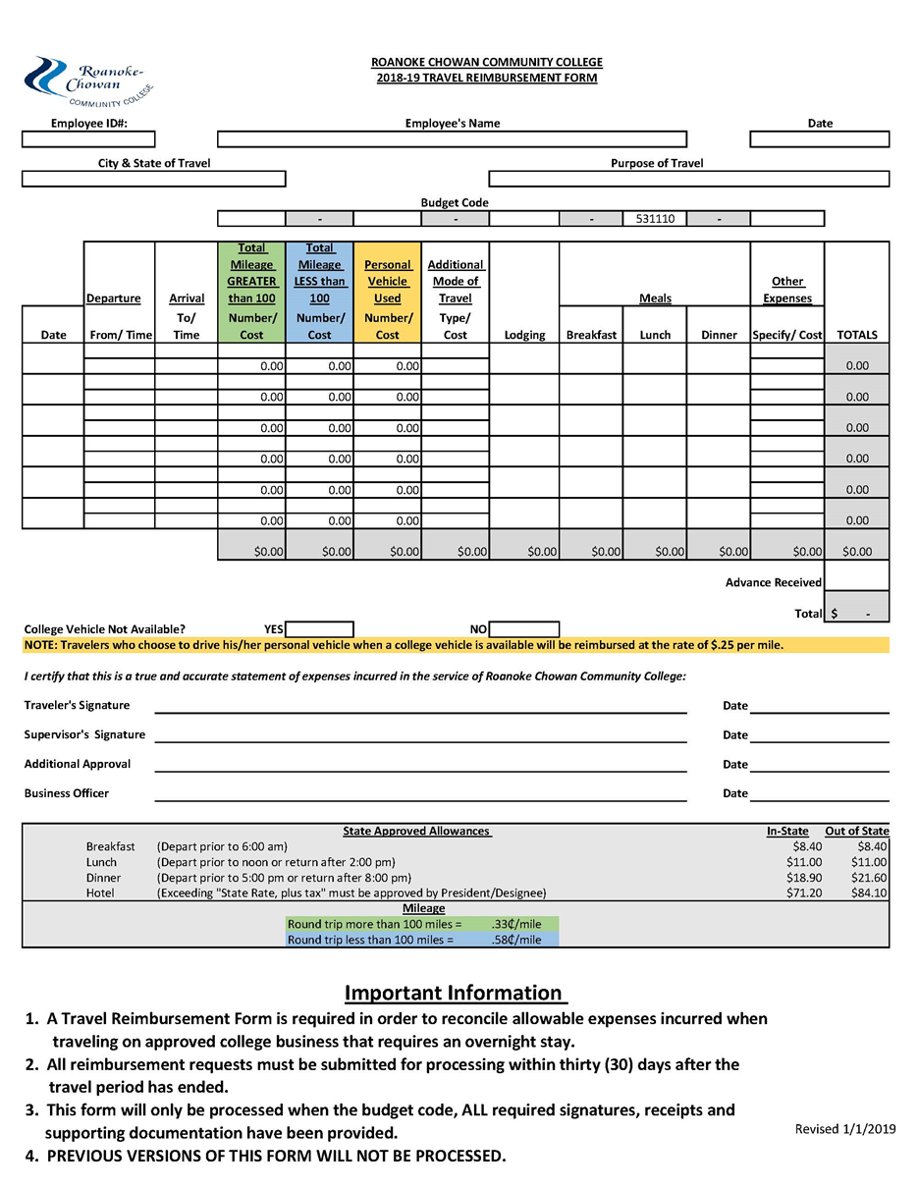

# Appendix B

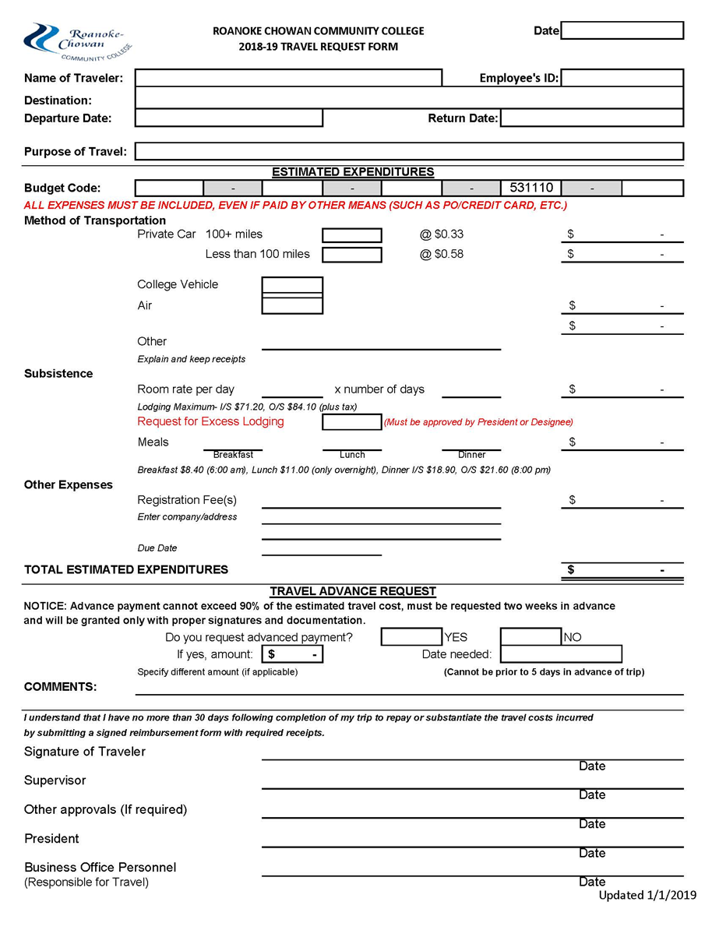

# Appendix C

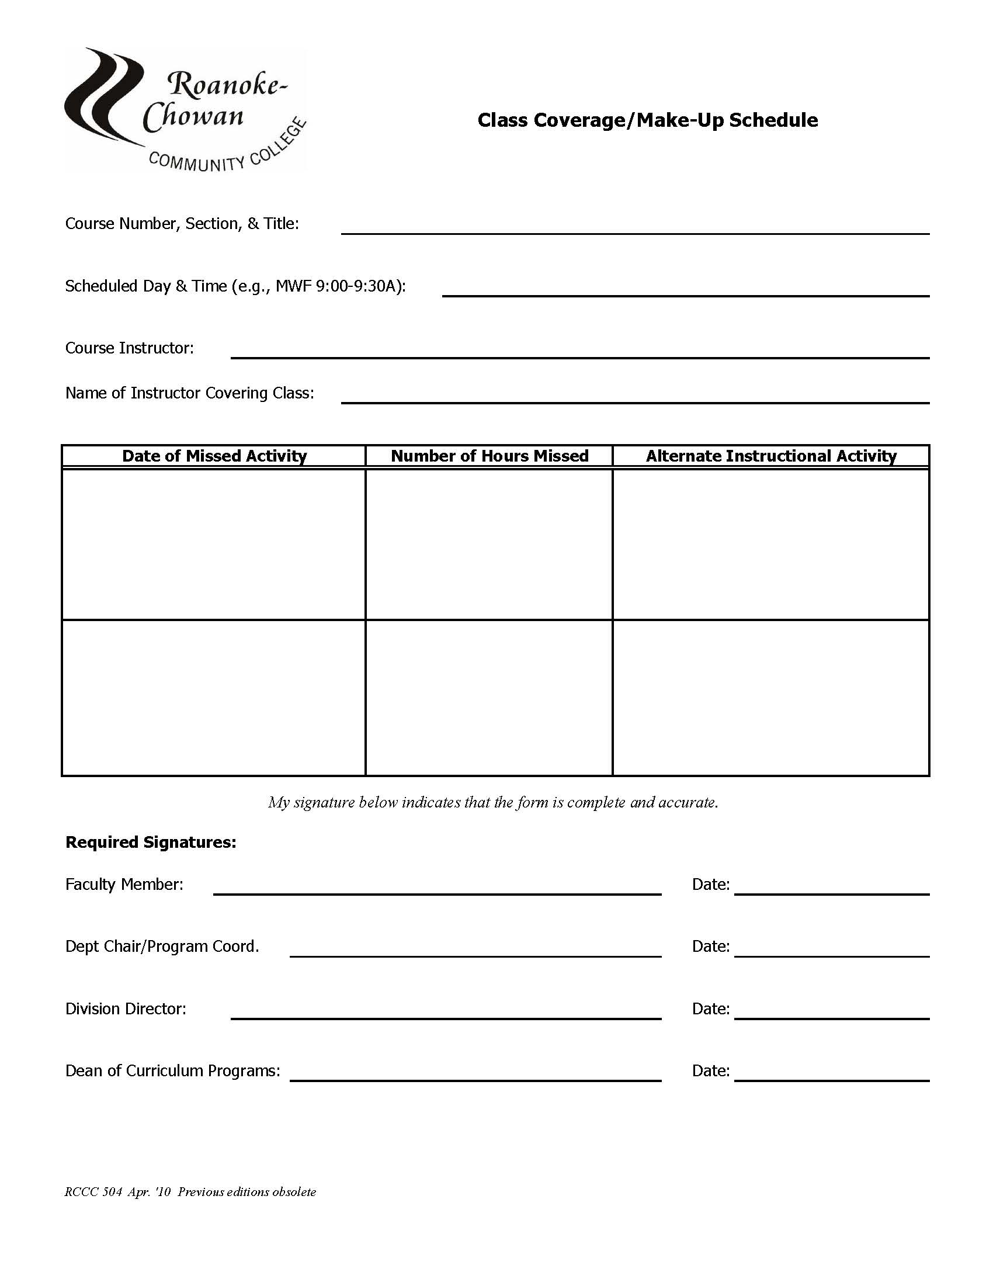

# Appendix D

|  |  |  |  |  |  |  |  |  |  |  |  |  |  |
| --- | --- | --- | --- | --- | --- | --- | --- | --- | --- | --- | --- | --- | --- |
| Curriculum Master Schedule  Course Listing Work Sheet Fall/Spring 20--  Fall/Spring 20-- | | | | | | | | | | | | | |
| **Course** | | | | | | | | | | | | | |
| **Crs**  **Prefix** | **Crs**  **No.** | **Sec**  **No** | **Crs**  **Title** | **CR Hrs** | **CT Hrs** | **Faculty** | **Instr Me- thod** | **Start**  **Time** | **End**  **Time** | **Days** | **Loca- tion** | **Fees** | **Capa- city** |
|  |  |  |  |  |  |  |  |  |  |  |  |  |  |
|  |  |  |  |  |  |  |  |  |  |  |  |  |  |
|  |  |  |  |  |  |  |  |  |  |  |  |  |  |
|  |  |  |  |  |  |  |  |  |  |  |  |  |  |
|  |  |  |  |  |  |  |  |  |  |  |  |  |  |
|  |  |  |  |  |  |  |  |  |  |  |  |  |  |

|  |  |  |  |  |  |  |  |  |  |
| --- | --- | --- | --- | --- | --- | --- | --- | --- | --- |
| Curriculum Master Schedule  Course Listing Work Sheet Fall/Spring 20-- | | | | | | | | | |
| **Course** | | | | | | | | | |
| **Title of**  **Book** | **Pub- lisher** | **Author** | **ISBN #** | **Edition** | **Quan- tity** | **Add'l Mate- rials** | **Initial Adop- tion Date** | **When**  **will this text be used again?** | **Verified**  **text is re- quired - YES** |
|  |  |  |  |  |  |  |  |  |  |
|  |  |  |  |  |  |  |  |  |  |
|  |  |  |  |  |  |  |  |  |  |
|  |  |  |  |  |  |  |  |  |  |
|  |  |  |  |  |  |  |  |  |  |
|  |  |  |  |  |  |  |  |  |  |



# Appendix E

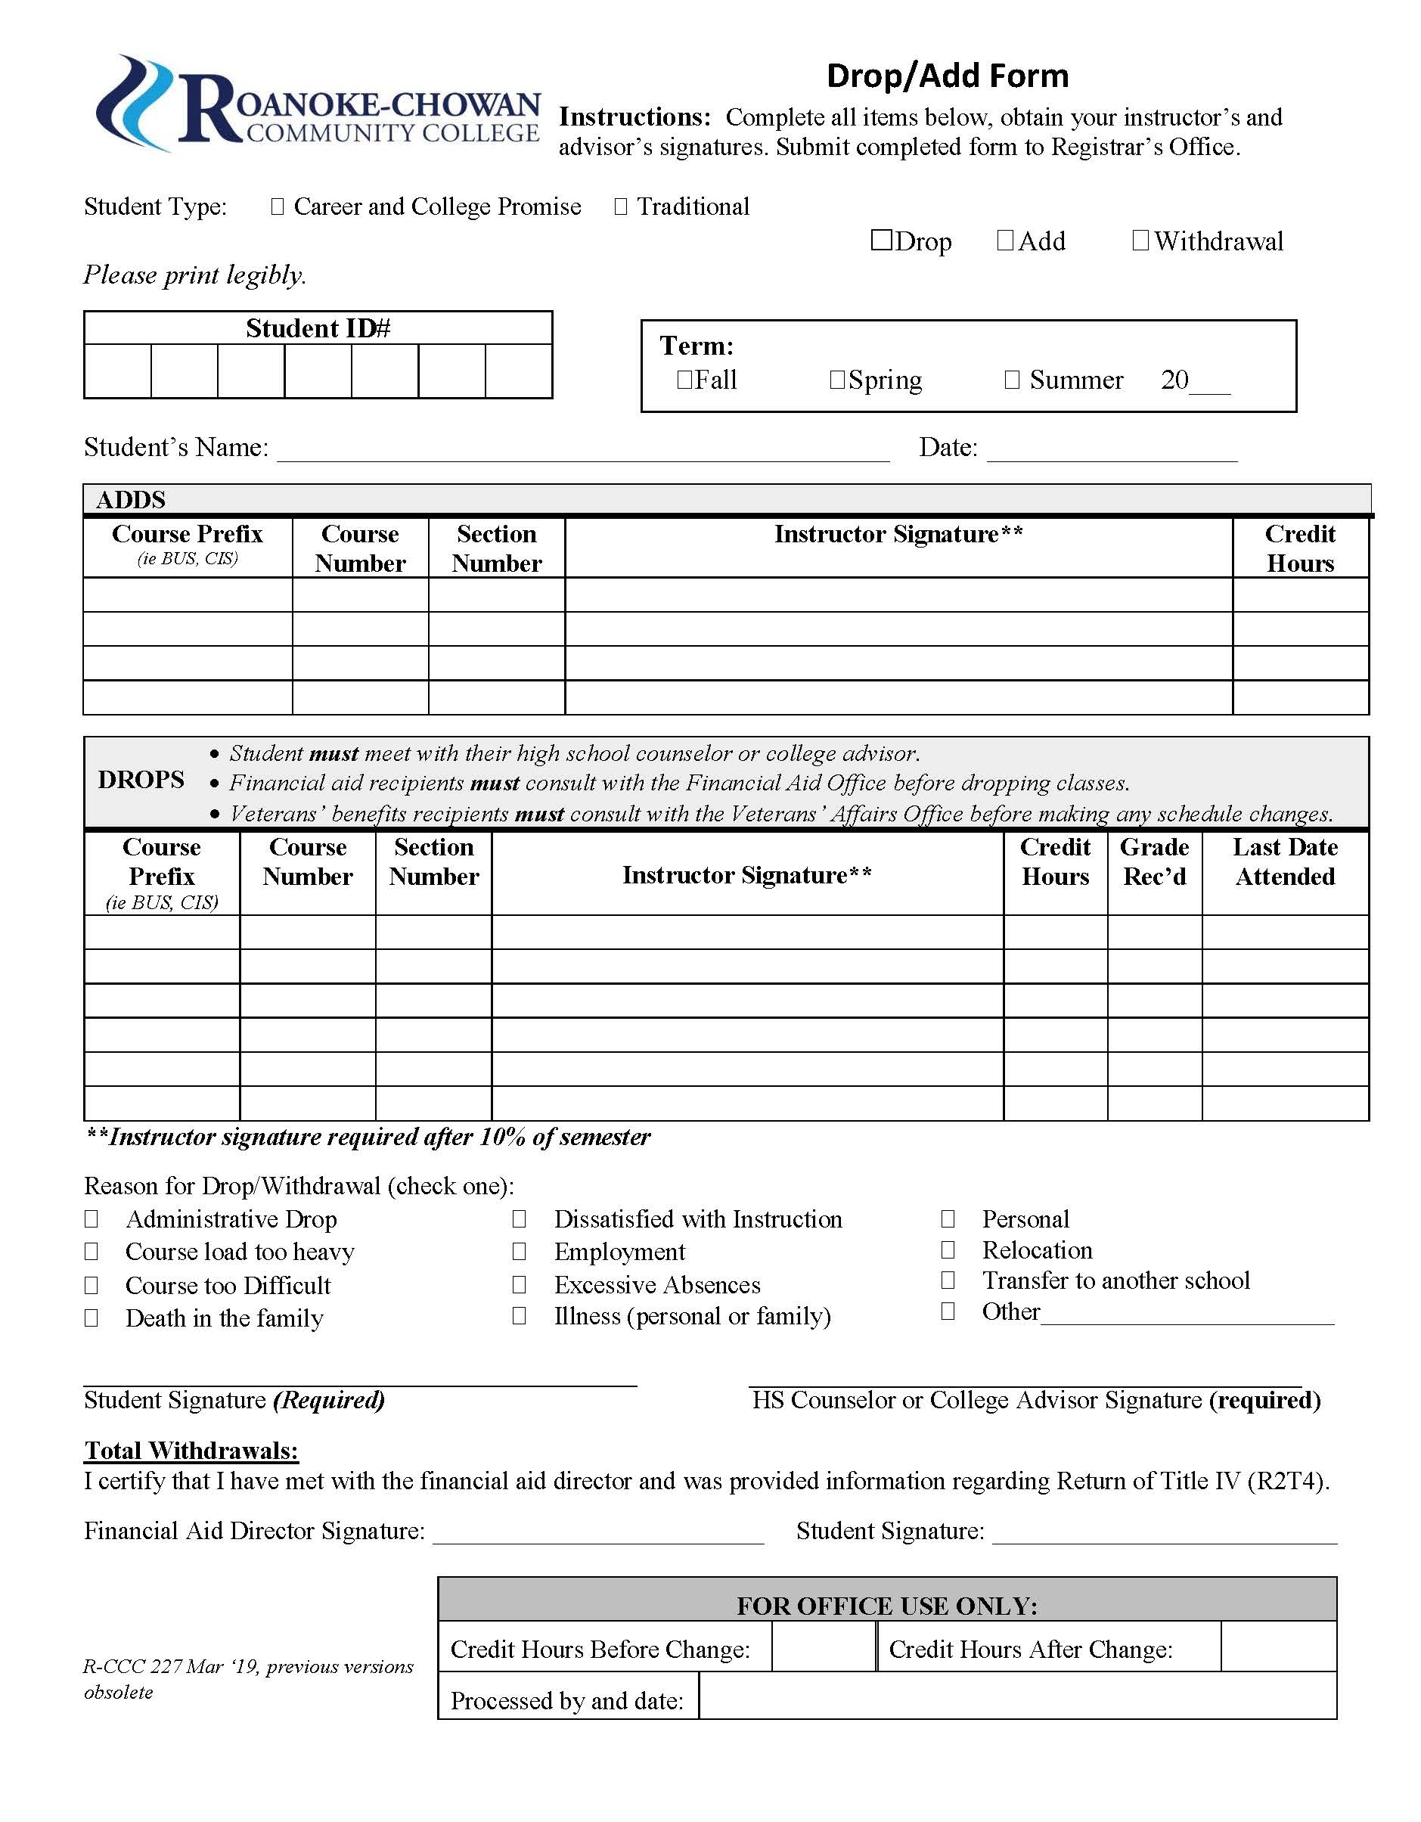

# Appendix F

**Roanoke-Chowan Community College Grade Change Report**

Student____________________ Curriculum_____________________ Date_________

Student ID No____________________ Advisor_____________________________________________

| Semester & Year | Course  Number | Section Number | Descriptive Title | Original Grade | New Grade | Grade Change Justification (required) |
| --- | --- | --- | --- | --- | --- | --- |
| Blank | Blank | Blank | Blank | Blank | Blank | blank |
| Blank | Blank | Blank | Blank | Blank | Blank | blank |
| Blank | Blank | Blank | Blank | Blank | Blank | blank |
| Blank | Blank | Blank | Blank | Blank | Blank | blank |

**“I” grades must be removed by the last day of the next semester, not including summer session.**

Instructor Signature__________________________________

Signature, Dean of Academic Affairs_____________________________

*Original Copy to: Records and Registration Photocopy: Instructor Academic Dean*

*R-CCC 218 July ’18 Previous editions obsolete*

# Appendix G

** Notification of Approval for “W” Grade**

In accordance with administrative process 09-0201, approval is granted for a **W** grade for the following student who withdrew beyond the 60 percent point of the following course because of extenuating circumstances beyond his/her control.

Student’s Name _________________________ Student’s ID#: ____________________

Course ________________________________ Date of Withdrawal: _______________

__________________________________________________ ______________________

Instructor Signature Date

__________________________________________________ ______________________

Lead Faculty Signature Date

_____________________________________________­_____ ______________________

Dean, Academic Affairs Signature Date

*R-CCC 254 July ’18 previous editions obsolete*

# Appendix H

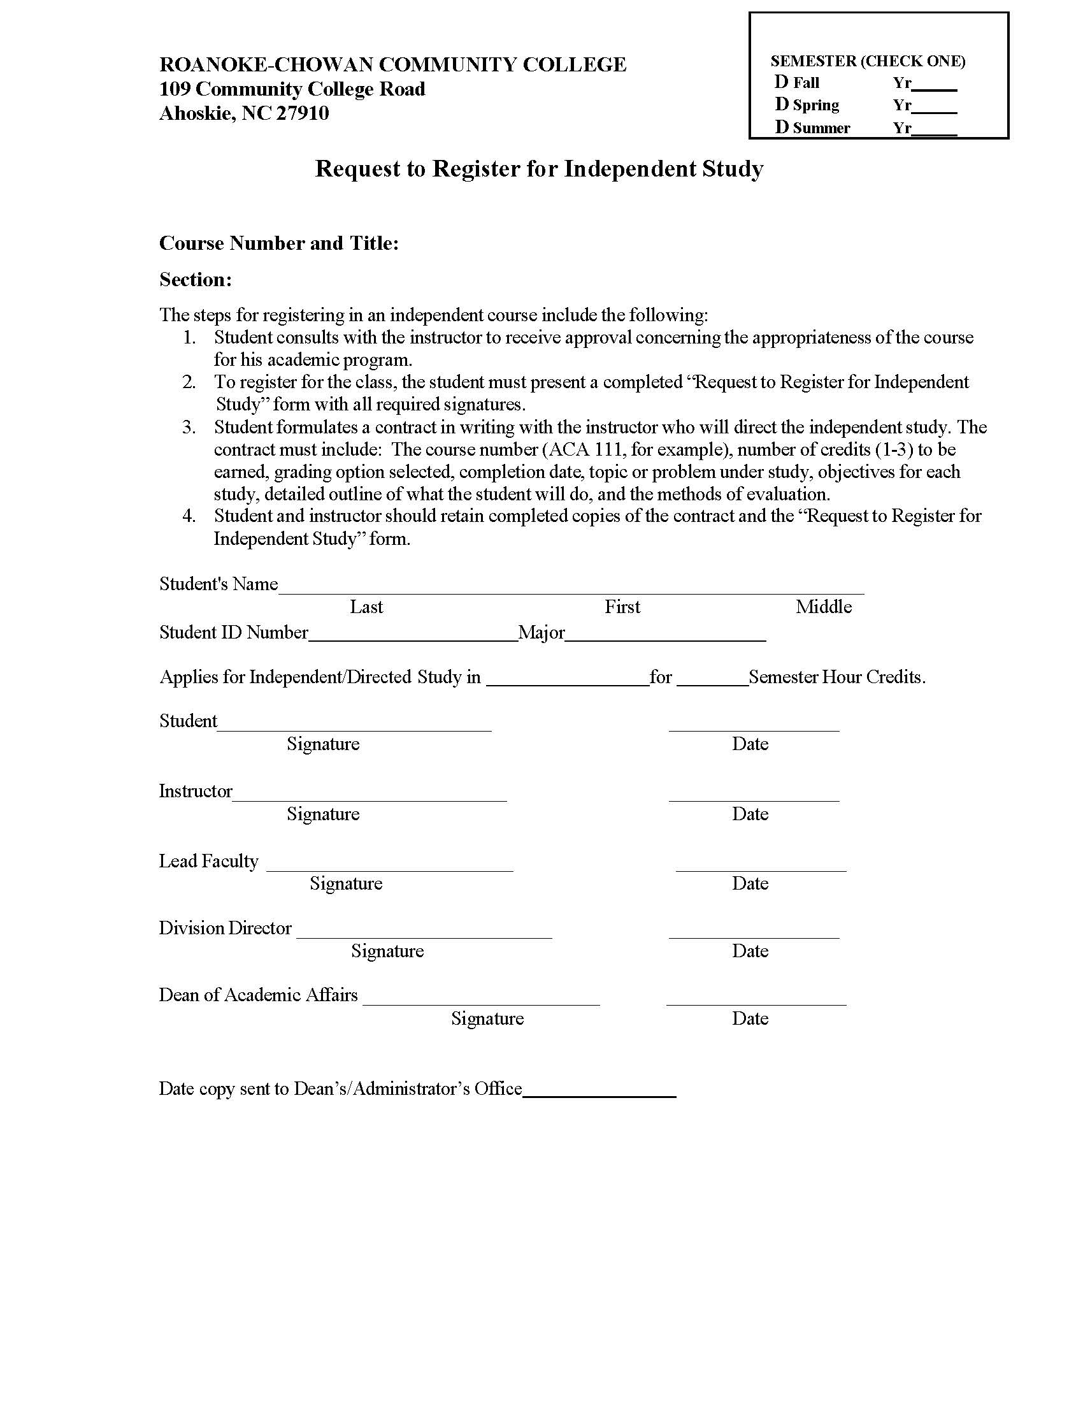



**Appendix H (continued)**

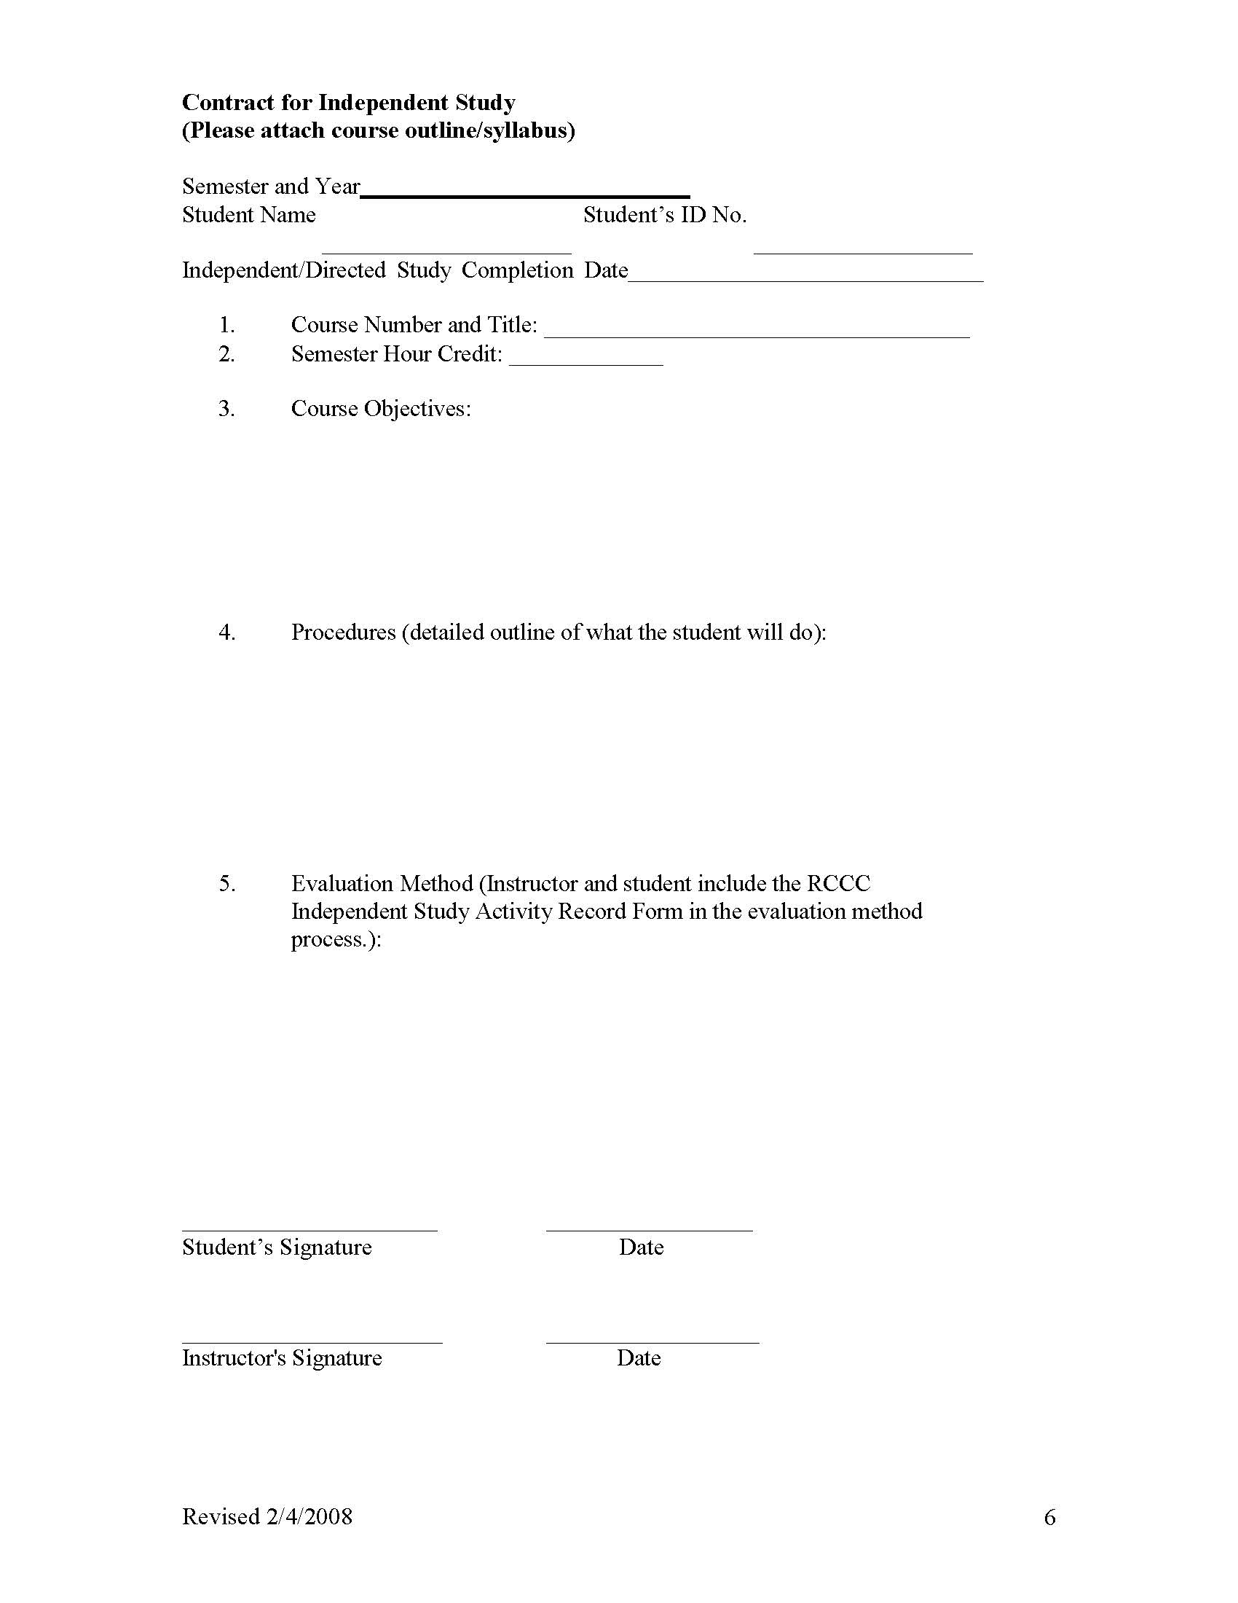

# Appendix I



**Course Number and Section: Title of Course**

**FA2019**

Credit Hours: Contact Hours:

This course will be taught % Face to Face & % Online

Pre-requisites: Co-requisites:

Class Meeting Day(s): Class Meeting Time(s):

**Instructor Contact Information**

Name, email, phone number

Office location and hours

**College Mission**

To provide world-class life-long educational and workforce training in order to meet the

emerging needs of the community and to improve the quality of life for the students we serve.

**Course Description**

Insert course description here

Topics to be Covered in Course

(Optional)

**Textbook and Required Supplies**

(Textbooks, ISBN, Title, Author, Publisher, etc.)

**Grading Scale & Policies**

Most assignments will be graded within **two** weeks of their due dates. Late submissions, when

permitted, will be graded by the semester's end. The final grade will be based on the following scale:

|  |  |  |  |  |  |
| --- | --- | --- | --- | --- | --- |
| **A** | 90-100% | **B** | 80-89% | **C** | 70-79% |
| **D** | 60-69% | **F** | 59% or lower |  |  |

*Syllabus and/or Schedule items are subject to change.* ***Revised:*** *August 2017*

**Appendix I (continued)**

**WP (**given when you drop or are dropped from course after the last date to drop without penalty if the

student is passing at that time; does NOT affect a student’s overall GPA)

**WF** (given when you drop or are dropped from course for excessive absences after the last date to drop without penalty; is calculated into a student’s overall GPA as an “F”)

**Course Evaluation**

Student Evaluations of Teaching & Learning will be conducted online beginning spring semester 2011 to ensure

efficiency and to target all curriculum courses. Students are encouraged to participate and provide meaningful feedback so that the quality of instruction can be enhanced for all curriculum programs.

**General Education Competencies and Assessments**

As a result of curriculum enrollment at Roanoke-Chowan Community College, students will be able to:

1. Communicate effectively in oral and written capacities.

2. Utilize appropriate technology skills.

3. Demonstrate knowledge of their roles and responsibilities in a diverse world.

4. Apply critical thinking skills enabling them to think logically and solve problems.

5. Apply quantitative reasoning skills to solve problems.

**Student Learning Outcomes and Assessments**

Upon successful completion of the course, you will have:

1. Outcome 1 goes here.

2. Outcome 2 goes here.

3. And so on. . .

**Outline of Class Activities for the Course**

Provide students with a tentative outline of activities that they can expect to occur throughout the semester, such

as assignments, projects, papers, tests, guest speakers, etc.

**Make-up/Late Assignment Policy**

All assignments will be due on the assigned due date. **Late assignments will only be accepted when**

**accompanied by a written statement detailing why you were unable to meet the deadline for the assignment.** Your statement should detail the reason (not an excuse) you didn’t turn an assignment in on time. Responsibility and accountability are the key words here. You are responsible for completing your work and are accountable for what you do and don’t do.

If you have an emergency (you are in the hospital or have had a death in your family, for example—be prepared to provide evidence of such emergency), that would be considered a valid reason for having missed an assignment deadline (most times). Technical difficulties is not an excuse for late work. You should not wait

until the last minute to turn in your work; if you do and you experience problems with your technology, you are still required to get the work in on time. Remember, responsibility and accountability!! Late work will only be accepted within two weeks of the missed assignment deadline.

*Syllabus and/or Schedule items are subject to change.* ***Revised:*** *January 2018*

**Appendix I (continued)**

**Class Attendance/Withdrawal Policy**

It is your responsibility to withdraw from this and every R-CCC course you take if you do not wish to be

enrolled in the course. However, it is the new college policy that I have to drop students who accumulate absences totaling 15% of total instructional course hours (for this course, 15% of total instructional course hours

= ? hours).

If you decide to withdraw from the class, it is your responsibility to contact your advisor or a staff member in Student Development Services to complete the proper withdrawal forms. You should not assume that you will be automatically dropped from the course just because you have stopped attending. After the 60% point in the course, any withdrawal from the course will be recorded as a “W,” “WP,” or “WF.” [Note: Your attendance policy can be more stringent than the college’s policy, but it cannot be more lenient.]

**Electronic Communication Device Policy**

(Address cell phone and other electronic device usage)

**Student Support Services and Learning Resources Center**

Student Support Services

Student Support Services is a federally-funded program that offers support services to a specific group of

students who may not otherwise achieve their true academic potential. These services include tutoring; counseling; a special study skills course; cultural enrichment activities; and workshops that focus on personal, social, and academic development. The program also has supervised computer labs that offer a wide variety of services to its students. To participate in the program, students must meet certain eligibility requirements and complete an application form. Forms may be obtained from the Student Support Services Office.

Student Development Services: Dr. LaTonya Nixon, Dean of Student Services

Amy Wiggins, Registrar

Student Support Services (includes tutoring services): Dr. Tanya Oliver, Director of Student Support

Services

Counseling Services

Guidance and counseling are an integral part of the overall educational program at the College. Students have

the opportunity to discuss personal, academic, or vocational concerns with a counselor. Counselors assist students in career planning, academic advising, placement testing, and referral services. Trained counselors work closely with faculty to identify and address specific needs of students. Counseling services provides an array of success workshops and seminars to enhance the student’s academic achievement and career development. Students are seen on an individual basis and are encouraged to schedule appointments; however, walk-ins are welcome.

Learning Resources Center

The Learning Resources Center (LRC) provides library, audiovisual, and computer-assisted instruction services

to support and enrich the College’s instructional programs. Open to community residents, as well as students and employees, LRC hours are 8 a.m.–7:30 p.m. on Monday-Thursday, and 8 a.m.–5 p.m. on Friday. The LRC hours vary during the summer sessions. To check out materials from the LRC, a library card is needed. Initial patron cards are free of charge and may be obtained upon request at the circulation desk. A validated student ID card serves as a library card for R-CCC students.

*Syllabus and/or Schedule items are subject to change.* ***Revised:*** *January 2018*

**Appendix I (continued)**

Research databases are organized collections of computerized information such as magazine articles, thousands of books, images, charts, graphics, multimedia and primary sources that can be searched to retrieve information. Databases can be general or subject-oriented with bibliographic citations, abstracts, and/or full text. These databases contain scholarly and peer-reviewed articles written by credible authors, such as journalists, researchers, and experts in their field. Since databases provide powerful search tools for narrowing results, users are able to more quickly find the information they need.

Research databases that are retrieved on the World Wide Web are generally non-fee based, lack in-depth indexing, and do not index proprietary resources. Subscription or commercial databases are more refined with various types of indexing features, searching capabilities, and help guides. Therefore, you are strongly encouraged to use these electronic databases as the beginning reference point instead of using search engines such as Google when searching for sources for research projects and papers.

The College's Library provides commercial databases for its users as well as non-fee databases. These databases are available from the library's website, [http://libguides.roanokechowan.edu/home.](http://libguides.roanokechowan.edu/home)

Bonnie Burkett, LRC Director/Librarian

Kellen Whitehurst, LRC Technical/Public Service Specialist

**Accommodations for Students with Disabilities**

The College fully supports the Americans with Disabilities Act and is committed to providing a barrier-free

learning environment in order for disabled students to achieve and maintain their maximum learning potential.

For additional information, please refer to the college’s 2018-2019 catalog and/or your student handbook. Designated parking spaces for the disabled are conveniently near each building.

**Wearing of ID Badges**

You are required to have and display your ID badge at all times when physically on this campus.

**Academic Integrity**

In addition to good academic performance, you should exhibit honesty and integrity. If there is any question

that academic honesty and integrity are not honored, you may be required to redo assignments in the presence of an instructor-selected monitor. Proof of dishonesty/cheating, including **intentional or unintentional** plagiarism, will make you subject to disciplinary action. In this course, the first incident of cheating will result in a “0” for that assignment. A second incident will result in an “F” for the course.

**A little more about plagiarism:** Trying to pass off someone else’s work (in whole or in part) or ideas as your own is plagiarism. Any time you use information or ideas that you did not already know, you need to give credit to the source. This applies to **all assignments** in this course. (**Note:** The information about plagiarism included here was taken from the instructor’s manual for *Cornerstone: Creating Success Through Positive Change*.)

*Syllabus and/or Schedule items are subject to change.* ***Revised:*** *January 2018*

**Appendix I (continued)**

**Plagiarism includes the following instances:**

a. Copying verbatim the work of another person without using quotation marks and a citation.

b. Paraphrasing the original ideas of another person without citation.

c. Obtaining a paper or commentary on the Internet or using a paper someone else has written and turning in that work as your own. Remember, if you can locate information online, so can I.

d. Submitting a paper for which you have already received credit in another course.

If there is any question that academic honesty and integrity are not honored, you may be required to redo assignments in the presence of an instructor-selected monitor. Proof of dishonesty, including intentional or unintentional plagiarism, will make students subject to disciplinary action.

Repeated acts of academic dishonesty will be referred to the Dean of Continuing Education and Workforce Development and Student Success, who has the authority to administer more severe disciplinary actions according to the Student Code of Conduct.

It is your responsibility to offer proof that your assignment submissions are your work and that all source material used is cited appropriately. You should save all notes, drafts, etc. to offer as proof should there be a question about the validity of your work.

**Influenza Pandemic Preparedness**

Faculty and staff have a responsibility to stay informed about any emergency information from the College and

to provide that information to their students and visitors. Additionally, students have a responsibility to stay informed about any current events and take necessary precautions to ensure their personal safety and health. In the event of a pandemic, students will be expected to follow all recommendations issued by the College.

**R-CCC Inclement Weather Policy**

The College will remain open as scheduled unless the following emergencies exist:

* Adverse or severe weather that would prevent students and employees from traveling or that would prevent normal operation of the College
* Quarantines or epidemics declared by medical authorities for public health purposes
* Critical power or utilities failure that would prevent normal operation of the College
* Declared national or state emergencies or restrictions imposed by civil authorities
* Other contingencies, such as fire

Announcements of closings will be made to the appropriate media outlets. Students will also be notified through the emergency/incident notification system by receiving a phone call and/or text message. Students should not call media automatically or assume that the College will be closed if no announcement has been made. Other public and private school closing in Hertford and surrounding counties do not mean that the College is or will be closed.

**Accreditation**

Roanoke-Chowan Community College is accredited by the Southern Association of Colleges and Schools

Commission on Colleges (SACSCOC) to award associate degrees, diplomas, and certificates. Contact SACSCOC at 1866 Southern Lane, Decatur, Georgia 30033-4097 or call 404-679-4500 for questions about the accreditation of Roanoke-Chowan Community College.

*Syllabus and/or Schedule items are subject to change.* ***Revised:*** *January 2018*

**Appendix I (continued)**

The Associate Degree Nursing program is approved by the North Carolina Board of Nursing located at 4516

Lake Boone Trail, Raleigh, NC 27607, (919) 782-3211. The Cosmetology program is approved by the North

Carolina State Board of Cosmetic Art Examiners. Contact information is 1207 Front St #110, Raleigh, NC

27609 or (919) 733-4117. The Barbering program is approved by the North Carolina Board of Barber Examiners located at 5809-102 Departure Dr., Raleigh, NC 27616, (919) 981-5210. The College is also approved by the NC State Approving Agency to assist students eligible for veteran benefits. Agency contact information is 120 Penmarc Dr., Suite 103, Raleigh, North Carolina 27603 or (919) 733-7535.

**Title IX Reporting**

Roanoke-Chowan Community College encourages students and employees to report sexual harassment/sexual

violence to the College’s Title IX Administrators. Sexual harassment is a form of sex discrimination that is prohibited by Title IX. It creates a hostile environment that is inappropriate for an environment conducive to learning and working. The College takes this very seriously. We are dedicated to providing a safe environment for students and employees and will respond immediately, effectively, and fairly to all complaints. Incidents should be reported to the following:

**Compliance Officers** Dr. LaTonya M. Nixon Dean of Student Services

109 Community College Road

Ahoskie, NC 27910

Office: Student Center, Room 111-F

[lmnixon@roanokechowan.edu](mailto:lmnixon@roanokechowan.edu)

P 252-862-1267

F 252-862-1355

Nicole Boone

Interim Director of Human Resources

109 Community College Road

Ahoskie, NC 27910

Office: Jernigan Building, Room 105 [nfboone8475@roanokechowan.edu](mailto:nfboone8475@roanokechowan.edu)

P 252-862-1310

F 252-862-1329

**Important Dates to Remember**

*Syllabus and/or Schedule items are subject to change.* ***Revised:*** *January 2018*

# Appendix J

**Web Attendance Quick Guide**

**Attendance Tracking**

1. Login to WebAdvisor **Faculty**

2. Click the **Web Attendance Tracking** link

3. Click the **Attendance Tracking** link

4. Complete the following steps to select course section meetings or contact hour sections for tracking attendance: Attendance should be recorded on each roster, including those with a separate lab or clinical.

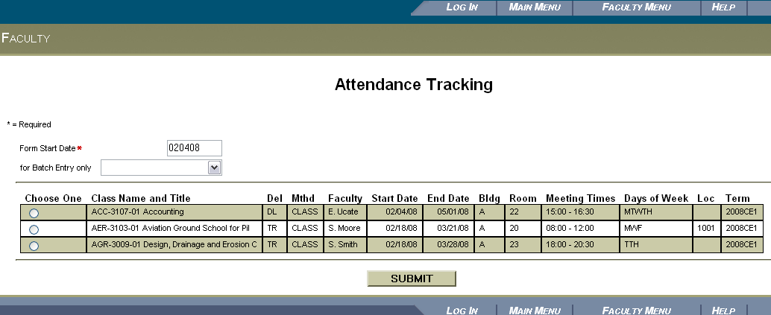

**Form Start Date** (required)

Enter the date for which you want to mark attendance.

Entry dates should be placed on the actual date the student initially demonstrates academic attendance as outlined below:

• Submitting a graded academic assignment;

• Taking an exam;

• Completing an interactive subject specific tutorial or computer-based instruction;

• Participating in online discussions about the class content and/or initiating contact with faculty to ask questions about subject matter; or

• Physically attending class (hybrid courses or seated courses).

**For Batch Entry only** (optional)

This is only used for cancelled class meetings (such as inclement weather closings) and previously unscheduled make-up classes (such as a Saturday meeting to make up for inclement weather closings). This will update **all students** in the course, so do not use this method for an individual student’s make-up assignments.

(Note: The Batch Entry process for “cancelled” and “make-up” is shown on pages 4—5.)

**Appendix J (continued)**

**Choose One** (required)

Select the appropriate roster.

After clicking on the **Submit** button, the **Attendance Entry** web form will be displayed.

**Attendance Entry**

The form will display the student names, status/status date (links to the student profile), No Show status, seat total, 10 scheduled meeting dates starting from the attendance start date entered on the Web Attendance Tracking web form, and the last date of attendance. Enter an attendance type of E to indicate the first day of attendance. **Any blank dates after E attendance types are considered present and are included in the attendance totals.**

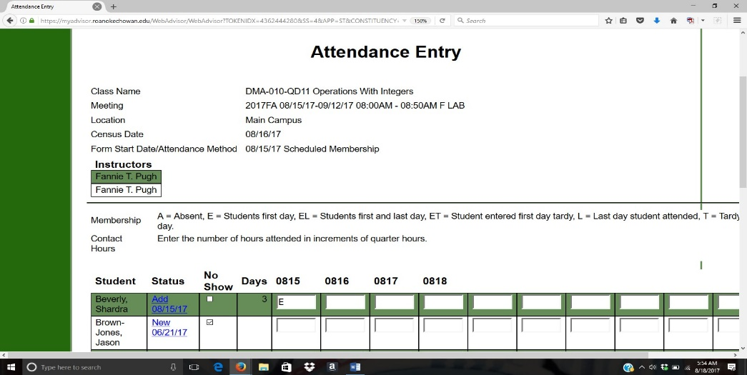

**Student Status**

Clicking the hyperlink beside a student name will link to the student’s profile.

**No Show**

1. Check the No Show box for any student not in attendance **by the census date (10% point)** of the course **after** you have entered the NP grade. Once a student has been marked a ‘No Show’ and saved, the field cannot be removed through the web process. If a student was marked No Show by mistake, you will need to contact the Registrar Office to have the status removed.

**Appendix J (continued)**

Please note that the student will remain on your roster unless the student is later dropped for another reason or marked for non-payment.

**Drops**

Students who have dropped the course during the drop/add period will be removed from the Web Attendance roster. In addition, students who have dropped are also removed from the “Grading” area in WebAdvisor because no grade is necessary for these students.

**Withdrawals**

Codes of “L,” “EL,” and “TL” are used to indicate the last day of attendance in a course. Faculty must enter one

of these codes for students who withdraw themselves or who are withdrawn by the instructor.

Note: Any attendance codes (including A), previously entered after the entry of the “L” status code on the

withdrawn student will need to be removed by spacing out the codes.

Faculty **must also submit** a Drop/Add form to ensure timely reporting to Financial.

Note: Any attendance codes (including A), previously entered after the entry of the “L” status code on the

withdrawn student will need to be removed by spacing out the codes.

**Attendance Types**

Valid codes for Scheduled Membership attendance are listed in the table below. Remember, we will not use the codes L, TL, or EL but the drop forms as noted above.

|  |  |  |
| --- | --- | --- |
| Code | Description | Comments |
| A | Absent |  |
| E | Entry | First day student entered class |
| ET | Date entered class, tardy | First day student entered class |
| EL | First, last date attended | First and last day student entered class, for withdrawals |
| T | Tardy |  |
| L | Last date of attendance | For withdrawals |
| TL | Tardy, last date attended | For withdrawals |

**Previous/Next**

This field will recalculate the Form Start Date and redisplay the form with a new list of dates. Note: You must check the first electronic signature box when going from previous/next pages or an error message requesting you check the electronic signature box will appear.

**Electronic Signature**

The first check box serves as a signature confirming the attendance information. This is required if data was added or changed. This includes blank dates after E or ET attendance types.

The second check box serves as a final submission indicating all attendance has been entered for the section meetings. **Do not check the final submission box until you have finalized ALL attendance for the semester.** Once final submission has occurred, the roster will be locked and faculty may not make any

**Appendix J (continued)**

changes to their web attendance roster. If you check this box by mistake prior to the end of the semester, you can have the roster unlocked. Please contact the Registrar Office to have this done.

**Submit Button**

An error will be displayed if the user does not enter valid attendance type codes or if data is entered for dates that occur in the future. The form will be redisplayed to allow the user to correct the invalid data.

**Review of Attendance Entry Steps**

**Step 1:** Enter Attendance Information (NS checkbox, A, E, ET, EL, T, L, TL)

**Step 2:** The first check box-required. **Do not check the final submission box until you have finalized all attendance for the semester.**

**Step 3:** Click the Submit button.

**Batch Attendance Entry—Class Cancelled**

Faculty complete the following steps to enter and maintain student attendance after selecting the **Class Cancelled** Attendance Entry Method and **Form Start Date** on the **Attendance Tracking** web form and clicking the **Submit** button. With the **Class Cancelled** option, the ‘Form Start Date’ **needs to be the date of the cancelled class**. In the example below, 0818 is the cancelled class date.

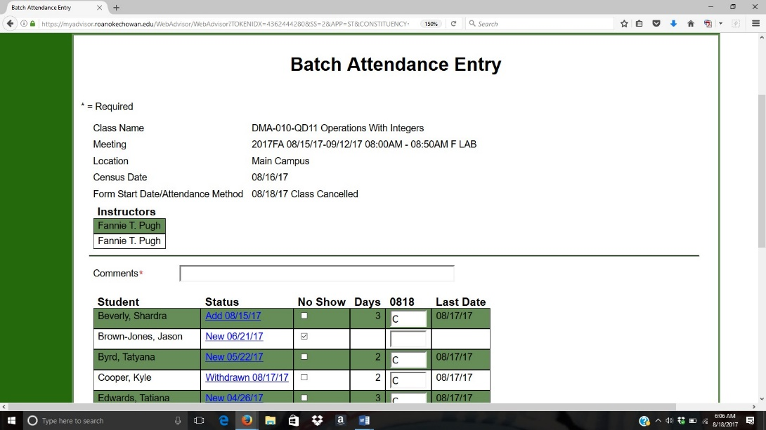

**Appendix J (continued)**

**Comments** (required)

Enter free form comments in this field explaining the reason for the cancellation **and** method for the make-up. Examples:

• College closed for inclement weather. Make-up assignment posted in Moodle.

• Instructor illness. Emailed students a reading assignment for the next class period.

**Attendance Type**

The entries in this field default to the **C – Cancelled** attendance type code. You must space out the “C” codes that populate for withdrawn students prior to submitting the makeup attendance. If you do not do this, you will get an error message and will not be able to complete your batch entry.

**Electronic Signature**

The first check box serves as a signature confirming the attendance information. This is required if data was added or changed. This also includes navigating the Previous/Next dropdown menu.

**Submit Button**

An error will be displayed if data is entered for dates that occur in the future. The form will be redisplayed to allow the user to correct the invalid data.

**Batch Attendance Entry—Unscheduled Membership (Make-up Days)**

The Unscheduled Membership (make-up days) entry will most likely only be used in the event that the academic calendar has to be altered due to inclement weather. Instructions for entering make-up days will be distributed on an as-needed basis. **Therefore, please do not use unscheduled makeup days unless instructed to do so by the Dean of Academic Affair and the Registrar**

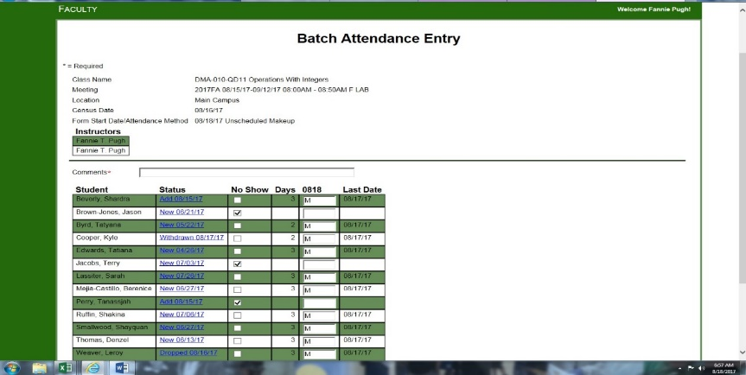

# Appendix K



# Appendix L

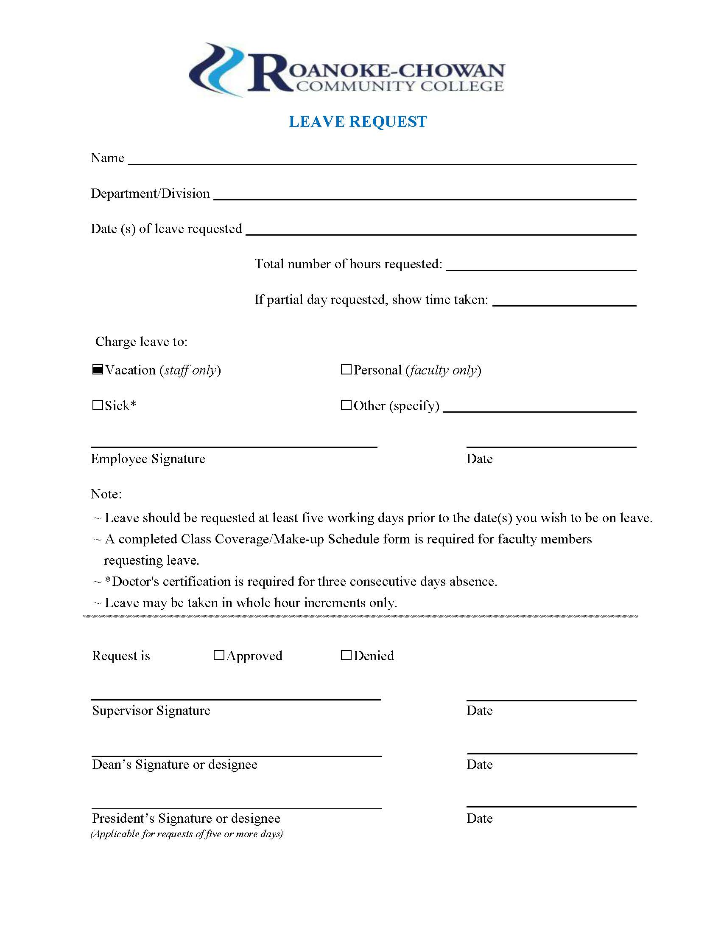

# Appendix M

