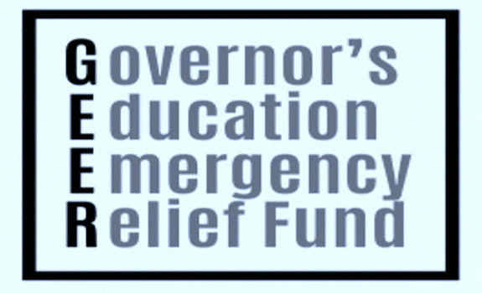****

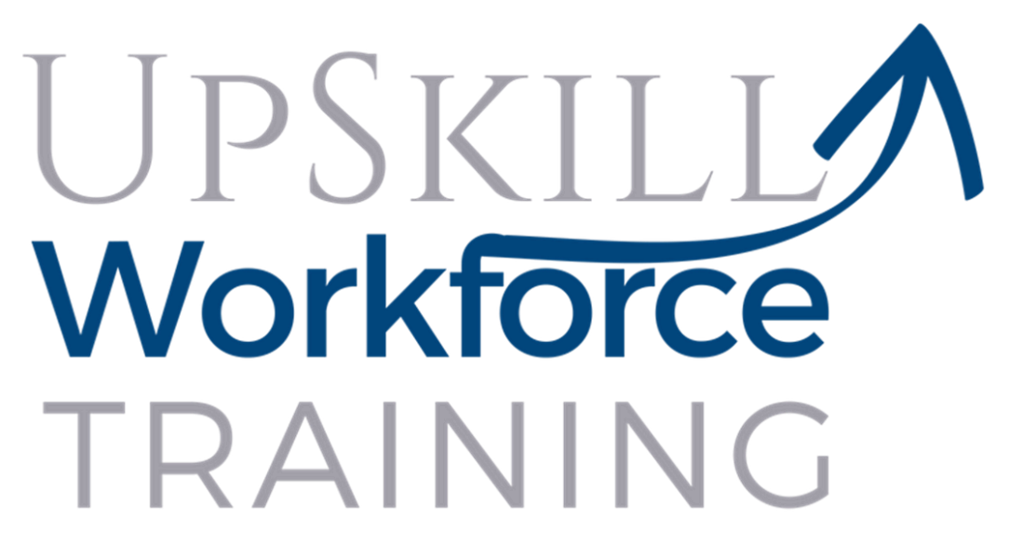

**The North Carolina Community Colleges Governor’s Emergency Education Relief Fund** **(GEER)** is available to assist NC residents who have been affected directly or indirectly by COVID-19. Through short-term occupational training, GEER scholarships will provide assistance to upskill and reskill workers to obtain marketable skills and quickly enter the workforce. The scholarship will provide assistance to qualified recipients who enroll in eligible courses through the College’s Continuing Education Department. Qualified students may receive up to $750 to cover such expenses as tuition, books, supplies, credentialing exams, transportation, childcare assistance, and other related educational fees.

**Eligible Continuing Education Courses**

*(96 credit hours or more leading to State and/or Industry Credentials)*

Advanced Manufacturing Institute, Certified Nursing Assistant I and II, Dietary Manager, Medical Billing and Coding, Pharmacy Technician, Phlebotomy, Commercial Driver’s License (CDL), Commercial Cleaning, Building Trades, Emergency Medical Services, Fire and Rescue Services.

**For more information and to apply for GEER, please contact:**

Wendy Vann

Associate Dean, Workforce Continuing Education

Office 125, Freeland Building ~ (252) 862-1234 ~ Email: [wpvann6919@roanokechowan.edu](mailto:wpvann6919@roanokechowan.edu)