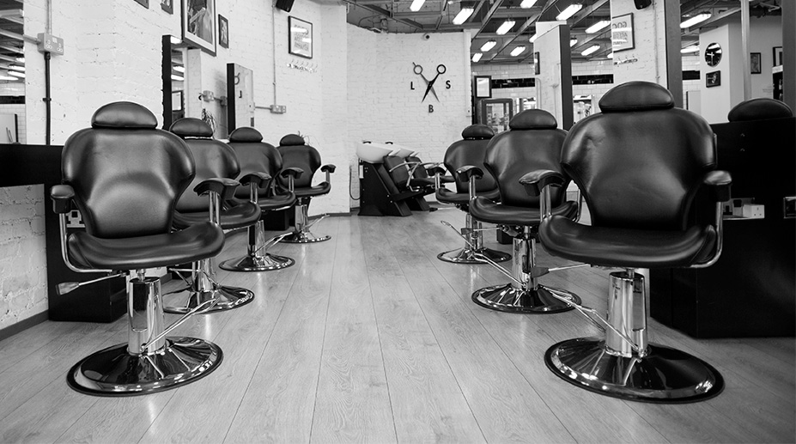
  - Barbering Program
Classes Begin
March 8, 2021

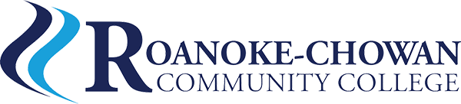

  - BAR–3100 Barbering (215 Hours)
  - March 8-May 20, 2021
  - Monday-Thursday 8:00 a.m.-1:00 p.m. (Hybrid)
This course provides instruction in classroom and clinical education necessary to sit for the NC Barber Licensing examination. Per the NC Board of Barbers curriculum, this training requires 1528 hours of training, plus successful completion of practical skills. After successful completion of the program, students are eligible to apply to the NC Board of Barbers and schedule a licensing exam.
Orientation: Thursday, February 25, 2021 - 10:00 -11:00 a.m.
140 Community Room, Freeland Building on Campus

Tuition: $180, plus student permit, textbook, kit, uniform, and additional fees
Scholarships Available: GEER (up to $750) and SECU

For more information, please call the Department of Continuing Education.
252-862-1234 or 252-862-1307

