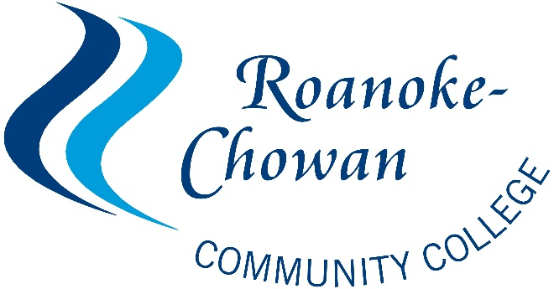

June 30, 2021

ARP/HEERF III Higher Education Emergency Relief Fund Student Emergency Financial Aid Grants
Roanoke-Chowan Community College signed and returned the Certification and Agreement to the US Department of Education offering assurance that the college intends to use no less than 50 percent of the funds received under Section 18004(a)(1) of the CARES Act to provide Emergency Financial Aid Grants to students in summer 2020. The college received an American Rescue Plan Act (ARP) Grant Award Notification from the US Department of Education on May 17, 2021 in the amount of $651,291 for Student Emergency Financial Aid Grants and accepted the terms and conditions as outlined.

Status of Distribution of Funds
As of June 30, 2021, R-CCC has distributed $518,288 to 202 students in ARP/HEERF III Emergency
Financial Aid Grants under Section 314(a)(1) of the CRRSAA.

