Roanoke-Chowan Community College
Policies and Procedures Manual

Title: College Sponsored Field Trips
Policy Number 08-0704

Revision Responsibility: Dean of Student Services

Date Adopted: October 17, 2007

COMMENTS:

POLICY

The college may sponsor trips for instructional programs and courses of study that may include some student organizations. The Instructor/Advisor will complete and submit the required forms seven working days prior to the date of travel. Travel must be approved prior to all field trips. A copy of the Field Trip/Student Organization Travel Authorization Request Form will be provided to the requestor prior to travel. If a college vehicle is required for travel, prior reservations must be made according to Roanoke-Chowan Community College Vehicle Policy.

When field trips involve no missed classes and are conducted by College clubs and organizations, the Advisor should file the appropriate forms with the Coordinator of Student Activities and the Dean of Student Services. When missed classes are involved, the below listed procedure should be used and signed by the appropriate Division Director and Dean of Curriculum Programs prior to submission to the Dean of Student Services.

A copy of the approved travel will be resubmitted to the requestor.

PROCEDURE

- Submit the Field Trip/Student Organization Travel Authorization Request Form along with the Travel Request form through appropriate channels.
- The Administrative Assistant for the Dean of Curriculum Programs will inform designated faculty members of the approved absence.
- A Liability Waiver form must be completed by each student traveling on the field trip and submitted with the Field Trip/Student Organization Travel Authorization Request Form.

FORM
Request for Travel (Employee Only)
Field Trip/Student Organization Travel Authorization Request (Attached)
RCCC Liability Waiver Form for Student Travel (Attached)

Revised: November 2015

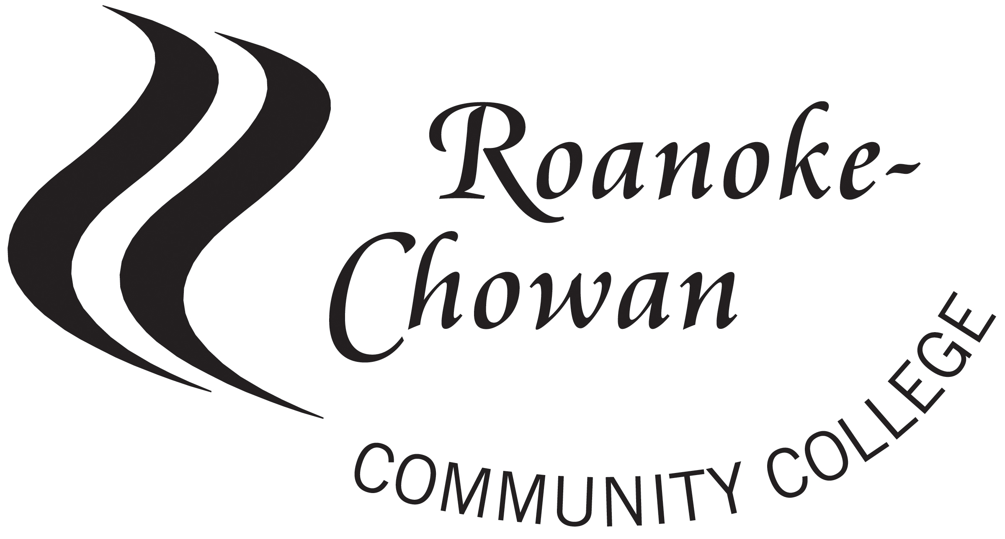

Field Trip Student Organization
Travel Authorization Request Form

Class/Organization/Group/Club Name:

Purpose of Trip:

Date(s) of Trip:

Destination: College

Phone # of hotel/event site:

Name of Instructor/Advisor traveling with club:
Instructor/Advisor emergency contact number:

Please list the names of the students participating and their emergency contact numbers:

Student Name (please print) Emergency Contact Number
___________________________________________________________________________________________________________________________________________________________________________________________________________________________________________________________________________________________________________________________________________________________________________________________________________________________________________________________________________________________________________________________________________________________________________________________________________________

Please attach additional paper if needed

Please list the names of additional advisors chaperones planning to travel:
__________________________________________________________________________________________________________________________________________________________________________

___________________________________ ___________________________________
Instructor/Advisor/Division Director Coordinator of Student Activities

___________________________________ ___________________________________
Dean of Curriculum Programs Dean of Student Services

Roanoke Chowan Community College
Liability Waiver Form for Student Travel

All students are required to sign a liability waiver form before traveling on a trip sponsored by Roanoke-Chowan Community College. Any person who is not a Roanoke-Chowan Community College employee who will accompany or chaperone the trip must also sign a release form.

I, ___________________________________________________, ________, a student of
(Student Name) (Age)
Roanoke-Chowan Community College will be participating in a college-sponsored trip to

I, the undersigned, in full recognition and appreciation of the dangers and hazards inherent in domestic and/or international travel to which I may be exposed during my participation in said trip, do hereby agree to assume all risks and responsibilities or activities undertaken; and, further, I do for myself, my heirs, and personal representative(s) hereby defend, hold harmless, indemnify, and release, and forever discharge Roanoke-Chowan Community College and all its officers, agents and employees from and against any and all claims, demands and actions, or causes of action, on account of damage to personal property or personal injury, or death which may result from my participation, and which result from causes beyond the control of, and without the fault or negligence of the College, its offers, agents, or employees, during the period of my participation in the said trip.

I have been advised by Roanoke-Chowan Community College to obtain personal medical coverage or else agree to bear the costs of injury of injury or damage myself. Students without coverage can purchase student accident insurance for a nominal fee from the College that covers limited medical and dental benefits.

It is further understood that I will act in accordance with the policies and guidelines set forth in the Roanoke Chowan Community College student handbook. Failure to comply with these policies and guidelines will result in disciplinary action as stated in said handbook.

I have read this release and agree to its terms

Signature of Participant: ___________________________________ Print Name: _________________________________
Participant’s Address: ___________________________________________________________________________________
City, State & Zip: ______________________________________________________________________________________
Health Insurance Provider/Carrier: _________________________________________________________________________
Policy Number: _________________________________ Today’s Date: _______________________________________

________ I have purchased insurance through Roanoke Chowan Community College
________ I declined purchasing insurance through Roanoke Chowan Community College

Please list any medical condition(s) that the college should be aware of: ___________________________________________
_____________________________________________________________________________________________________

